FDDI PATNA
BIHAR SKILL DEVELOPMENT MISSION – 2017-18
Footwear cutting and closing
THREE MONTH PROGRAM
It’s Objective, learning outcomes, Modules, assessments and material list

CERTIFICATE PROGRAM IN CUTTING – CLOSING / LEATHER GOODS

Submitted to :-  INDUSTRY DEPARTMENT, BIHAR GOVERNMENT | Submitted By :- Footwear Design & Development Institute Patna
 | Session – 2017-18

Certificate Course in Footwear Cutting and Closing
- Course Id- FC&C
- Candidate Eligibility : 10th Passed
- Course Duration: Three Months

CONTACT DETAILS OF THE BODY SUBMITTING THE QUALIFICATION FILE
Name and address of submitting body:
FDDI, AMHARA BIHTA
Ministry of Commerce and Industry
Name and contact details of individual dealing with the submission

Name : Mr. Sanjeev Mishra

Position in the organization : Campus Incharge

Tel number(s) : 9910286739
Website :www.fddiindia.com

E-mail address : sanjeevmishra@fddiindia.com

List of documents submitted in support of the Qualifications File
- Curriculum Document

SUMMARY

Qualification Title | Certificate in Footwear Cutting and Closing
Qualification Code | FC&C
Nature and purpose of the qualification | Nature  3 months Certificate Course in Footwear Cutting and Closing  Purpose  Explain the basic elements, features of designs and styles of footwear.  To make a complete shoe with hand lasting (selected design) for sample development.  .
Body/bodies which will award the qualification | Footwear Design and Development Institute
Occupation(s) to which the qualification gives access | Footwear technology
Entry requirements and / or recommendations | 10th PASSED

AIM
The aim of the program is to build Design-Techno-Managers and Professionals in the field of Fashion Leather Accessory Design and Manufacturing Sector. The aim is to create multi-disciplinary professionals who will cater to growing need of the Industry and contribute in this constantly changing and continuously upgrading Fashion Leather Accessory Design and Production Sector. The graduates of this program will act like a catalyst to change the emerging face of the Leather Product Sector by adding value based design, technical inputs and production support to meet the challenges of the global players; thus contributing to the growth and up-liftment of the Indian Fashion Leather product Industry.

1.2 STRUCTUE
The three-year program is focused to concept building in the area of Fashion Leather Accessory (Goods & Garments) Designing and Manufacturing Technology. Students are offered specialization in Designing, Production and Merchandising.

1.3 CONTENTS
Design Foundation: This being the first introductory module of the entire curriculum, we emphasize in opening the horizons of the individuals and try to build the ethical and professional competency. This two semester rigorous training exposes the individuals to varied world of fundamental realities of design. The subjects broadly taught during the design foundation are: Illustration Techniques, Geometric constructions, Analytical & Technical Drawings, Elements of Design, Color& Composition, Product Form & Design, Ergonomics, Presentation Techniques, Material Science & Leather Technology, Principles of Management, Fundamentals of Marketing, Finance& Human Resource Management and Overview of Fashion. Technical Foundation: During this year students understand the fundamental and the latest technical developments which govern the growth of the Indian Fashion Leather Product Sector. The modules include: Product Knowledge and overview of Fashion Leather Accessory (Goods & Garments) Design, Leather Cutting, Leather Stitching, Pattern Making, Basic Construction Techniques, Various Leather Machines Operations, Use of Tools and Accessory in Leather Goods & Garment Manufacturing, Identification and Finishing of Leather Goods, Production and Operation Management, Costing, Quality Control, Production Planning and real life industrial projects.

This phase of the training will add the grace and glamour to the well-groomed professionals and graduates of the Fashion Leather Accessory Design discipline. The learning amalgamation of the design concepts and knowhow of the technology will always keep them a league ahead in the professional arena. We emphasize on the realistic and market driven inputs which the key to a successful professional are. The modules are: Design Process & Methodology, Fashion Trends, Forecast and Analysis, Design Conceptualization and Range Building, Design Projects in Leather Goods, Garments & Accessory Collection Development, CAD, Leather Goods & Garment Design and Manufacturing Techniques, Leather Goods & Garment Pattern Development and Production Techniques, Classroom and Industrial Design Projects, Business Communication & Presentation Techniques, Product Documentation, Product Photography, Final Design Collection Development and Guided Industrial Internship.

MATERIAL REQUIRED :-

A).RESOURCES / MATERIAL REQUIRED FOR GARMENTS

Machineries, tools & equipments and consumable materials
I | Machineries
No. | List | Specification | Purpose | Quantity Per trainee
1 | Stitching Machine | Medium duty | For leather stitch | 1 for 2 trainees
2 | Stitching Machine | Light duty | For lining stitch | 1 for 3 trainees
3 | Ironing machine | With Heat adjustable | For reinforcement attaching and finishing | 1 for 6 trainees
4 | Cork Button attaching machine | Manual | For button attaching | 1 for 12 trainees

II | Tools and equipments
No. | List | Specification | Purpose | Quantity Per trainee
1 | Long tables | Long and Inclined | For pattern making and cutting | 1 for 1 trainee
2 | Standard table | Standard and straight | For folding and assembling | 1 for 2 trainees
3 | Cutting matt | Plastic | For cutting | 1 for 1 trainee
4 | 50 cm rulers | Steel | For pattern making | 1 for 1 trainee
5 | Set squares | 900 | For pattern making | 1 for 1 trainee
6 | Hip curve | Plastic | For pattern making | 1 for 1 trainee
7 | French curve | Plastic | For pattern making | 1 for 1 trainee
8 | Tracing wheel |  | For pattern making | 1 for 1 trainee
9 | Long rulers | 1 mtr | For pattern making | 1 for 1 trainee
6 | Fixers | 0.7 | For pattern making | 1 for 1 trainee
7 | Scissors | 10” | For pattern making, cutting and stitching | 1 for 1 trainee
8 | Cutter holder | Small size | For pattern making and cutting | 1 for 1 trainee
9 | Thread trimmer | Small size | For stitching | 1 for 1 trainee
10 | Glue can | Plastic | For gluing | 1 for 1 trainee
11 | Hammer | Plastic | For folding and assembling | 1 for 1 trainee
12 | Puncher | Rotary | For punching | 1 for 12 trainees

III | Consumable materials
No. | List | Specification | Unit | Quantity per trainee
1 | A4 paper |  | Ream | 1
2 | Drawing paper |  | Ream | 1
3 | Cell carton | 250 gm | Ream | 10
4 | Scotch tape | 25 mm | Roll | 1
5 | Pencil |  | Pcs | 1
6 | Lead | No. 7 | Tube | 1
7 | Leather | Sheep garment (black and brawn) | Sq.ft | 160
8 | Lining material | Nylon | Mtr | 6
9 | Non-woven | Thin | Mtr | 6
10 | Marking chock |  | Pcs | 1
11 | Shoulder pad | Ladies and men’s | Pairs | 4
12 | Zipper | No. 5 Metallic | Pcs | 3
13 | Zipper | No. 3 plastic | Pcs | 2
14 | Glue | Temporary | Kg | ½
15 | Cork button | No. 36 | Pkt | 1 for the class
16 | Jacket Snap | Golden/Silver | Pkt | 1 for the class
17 | Needle | As per stitching machine | Pkt | 4 for the class
18 | Thread | Polyester (No. 40 and 60) | Cone | As per the number of stitching machine available

B).RESOURCES / MATERIAL REQUIRED FOR LEATHER GOODS.

CONSUMABLE MATERIAL
Sl.no | Item | Specification | Quantity/person | Remarks
1 | Pattern paper | Cell carton | 1 rim
2 | A-4 Size paper | Normal | 1 rim
3 | Cutter | Olffa | 1
4 | Cutter blade | Olffa | 2 doz
5 | pencile | DOT | 1
6 | eraser | White in colour | 1
7 | Sheep napa |  | 20 ft2 | Ladies bag
8 | Pull up leather | Dark brown | 20 ft2 | Gent bags
9 | Cow softy/ different coulor/ |  | 20 each color | Ladies bags
10 | Died leather | Black | 30 ft2 | Wallet and belt
 | Thread | 40/3 | 2 cone | 1=no 40  1=no 60
 | Glue | cm-43 | 1kg
 | lining | Kaki | 5 meter
 | Pue-foam |  | 2 meter
 | velodone |  | 2 meter
 | needle | 120/ 110 | 1doz each
MACHINERIES
1 | Flat bed machine/ stitiching/ | Heavy duty | 1machine /3persons
2 | Cylinder arm sewing machine | Heavy duty | 1/all
3 | Skiving machine | Protex | 1/ all
4 | Sewing machine | Light duty | 1/2person
TOOLS AND EQUIPMENTS
1 | Steel ruler | 50 cm | 1
2 | Divider |  | 1
3 | Cutting board |  | 1
4 | Load |  | 1
5 | Steel ruler | 100 cm | 1/ 3person
6 | Sharpener |  | 1
7 | Cutting table /bench work operation |  | 1 / 2 person
8 | Scissor |  | 1
9 | Hammer |  | 1
10 | Revolving punch |  | 1 / 3 person
11 | Awl |  | 1
12 | Thread trimmer |  | 1
ACCESSORIES
1 | Zipper (No 5 )plastic |  | 5 MTR
2 | Zipper (No 3 plastic ) |  | 4 PCS
3 | O-Ring (2,2.5&3cm Color Golden, Silver ) |  | 4 PC
4 | D-Ring (2,2.5&3cm Color Golden, Silver ) |  | 4 PC
5 | Rectangular Ring/ adjustment buckle (2,2.5&3cm Color Golden, Silver) |  | 5 PCS
6 | Buckle (2.5,3,3.5&4cm color Golden, Antique & Nickel different shape) |  | 3 PCS
7 | Flat magnet button (small, medium & large color silver or golden) |  | 5 SET
8 | Piping Cord |  | 4 MTR
9 | Oil can plastic |  | 1 PER PERSON
10 | Snap ring 15mm as per the sample |  | 10 SETS

FINAL PROJECT IN LEATHER GOODS.

Project 1 | GENTS BAG | 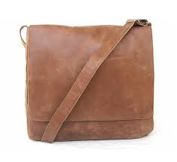
Project 2 | U SHAPE BAG | 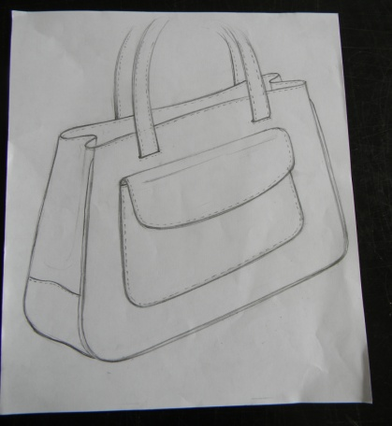
Project 3 | KELLY BAG | 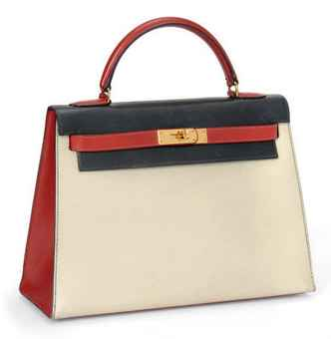
Project 4 | T GUSSET BAG | 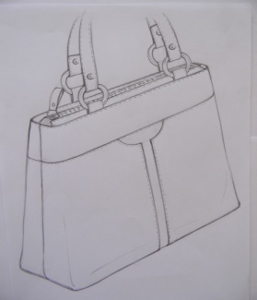
PROJECT 5 | OVAL BASE BAG | 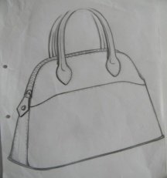
Project | WALLET | 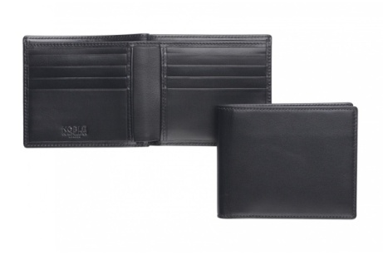
Project | BELT | 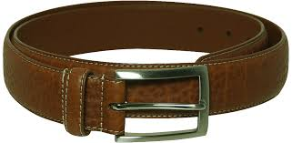

- OBJECTIVE OF THE COURSE: -

This module comprises of full shoe making techniques which includes designing, pattern cutting, closing, and drafting methods with hand lasting techniques. It also enables students to understand the fundamental concepts of footwear as a product, structure and basic parts of the foot, different sizing systems, various styles of shoe , lasts and its types, masking methods , to prepare mean form , patterns of different styles .

It attempts to introduce the fundamentals concepts of hand cutting and machine cutting, types of blades, understanding different types of dies used for the machine cutting and its storage. Under this course the student will understand to operate swing arm machine, splitting machine, stamping machine with its parts and functions.

Further this course attempts to introduce the fundamental concepts of sewing machine control and adjustment process, top threading, bottom threading & bobbin binding and needle changing. The students will also be taught about the relationship between machine, needle and material. The students will know about the different types of threads, consumption of thread, different types of adhesives and different types of reinforcements used in upper, they will stitch a full upper themselves (for a selected design) .

At the next level of the course the student will be introduce to the fundamental concepts of carrying out the preparation activities, Drafting methods , performing lasting operations, different methods and sequence of operations for hand lasting, quality check points for each operation.

At the final stage the student shall be able to prepare a complete shoe by self designed patterns, transforming cut patterns of material (leather/synthetic) into a full upper, shaping it with the bottom profile with hand lasting methods by pasting sole.

- LEARNING OUTCOMES :-

- Explain the basic elements, features of designs and styles of footwear.
- Identify the last based upon the fashion, design and constructions.
- Mask the last according to work specification
- Develop the mean form for the selected last.
- Develop the upper standard, lining standard, insole, toe puff and counter stiffener standard.
- Develop the variations of the basic styles.
- Prepare a design (men/ladies) for further sample development.
- Brief Introduction to the cutting/clicking department.
- Brief over various types of blades.
- To cut mix pattern of synthetic exercise.
- To operate swing arm machine, splitting, stamping machine knowledge of parts & functions.
- To understand methods of dies storages and its types.
- Brief study of CG leather, quality areas, lines of tightness & stretchiness in hide/skin.
- Brief introduction to nesting, layouts of cow sides (D/O) on brown paper by tracking methods.
- Cut patterns of full upper, lining (selected design) for further sample development.
- Know about the safety points, good working habits, bench layout and adjustment of sewing machines
- Operate the flat bed, post bed, cylinder arm machines and their parts & functions
- Know about the different types of needles used in different types of machines.
- Know about the different types of adhesives, needles.
- Stitch different types of Synthetic exercises with standards and quality check points.
- Stitch complete upper (selected design) for further sample development.
- Understand the concepts and fundamentals of hand lasting, its tools.
- Understand the different methods of lasting and method of producing footwear.
- Know about the hand lasting and the methods of attaching lining, insole, toe-puff and counter stiffener
- To make a complete shoe with hand lasting (selected design) for sample development.

- MODULE- THREE MONTHS (FOOTWEAR CUTTING AND CLOSING)
DURATION :- THREE MONTHS
FOOTWEAR CUTTING AND CLOSING
MODULE CODE & NAMES |  | Code :- BSDM 2017-18  Module :- BSDM (FOOTWEAR CUTTING AND CLOSING)
RATIONALE & OBJECTIVE OF THE MODULES |  | This module enables trainers to understand the fundamental concepts of footwear as a product, going through each operations from last selection to pattern cutting, cutting of component of each part of upper and lining on the material (leather/synthetic etc), assembling of each cut component into a full upper with the help of sewing machines, assembling bottom components, drafting techniques to hand lasting process will help them to understand a full shoe making operations.
MODULE COMPETENCE |  | At the final stage the student shall be able to prepare a complete shoe by self designed patterns, transforming cut patterns of material (leather/synthetic) into a full upper, shaping it with the bottom profile with hand lasting methods by pasting sole.
MODE OF DELIVERY |  | Practical and theoretical
Sl.N | ELEMENTS/TOPICS |  |  | DAYS
1 | BASIC OF FOOTWEAR TECHNOLOGY |  |  | 15 days
 |  |  | 1.1 Styles /Types of footwear
 |  |  | 1.2 Types of lasts
 |  |  | 1.3 Selection of last
 |  |  | 1.4 Material used in footwear
 |  |  | 1.5 Process involved in making footwear
 |  |  | 1.5 Flow chart of footwear making process
 |  |  | 1.6 Machines used in making footwear
2 | ADVANCE DESIGN TECHNIQUES |  |  | 15 days
 |  |  | 2.1 Develop making
 |  |  | 2.2 Construction of mean form
 |  |  | 2.3 Construction of upper / lining standard
 |  |  | 2.4 Develop basic style
 |  |  | 2.5 Develop full shoe patterns with standard
3 | ADVANCE CUTTING OPERATIVE TECHNIQUES |  |  | 15 days
 |  |  | 3.1 Introduction to cutting technology
 |  |  | 3.2 Cutting methods / Nesting / Interlocking
 |  |  | 3.3 Mix pattern vinyl cutting exercise
 |  |  | 3.4 Tools used in hand cutting – Introduction
 |  |  | 3.5 Hand cutting of upper and lining patterns
 |  |  | 3.6 Splitting of cut components
 |  |  | 3.7 Stamping of all component
 |  |  | 3.8 Quality check parameter
4 | ADVANCE CLOSING OPERATIVE TECHNIQUES |  |  | 15 days
 |  |  | 4.1 Prepare sequence of operation of designs
 |  |  | 4.2 Assembling material for fitting
 |  |  | 4.3 Develop marking patterns – marking
 |  |  | 4.4 Stitching – practice over vinyl upper
 |  |  | 4.5 Stitching – complete upper
 |  |  | 4.6 Quality check points

- ASSESSMENT / EXAMINATION

1 | BASIC/INTERNAL ASSESSMENT | ( Mid of the stage) | P/T | MARKS
 |  | - Prepare vinyl upper. | P | 25
 |  | - Internal assessment test on shoe making process. | T | 25
2 | FINAL PROJECT PRESENTATION | ( Final stage of completion of session) |  | 100
 |  | - Display & Submission - Designed standards with patterns. | P
 |  | - Display & Submission - two men’s complete footwear samples. | P
 |  | - Display & Submission - two ladies complete footwear samples. | P
 |  | - Display & Submission any self designed footwear sample on given last. | P
 |  | - Presentation through final product display with tech. Specification. | P
 |  | - Final test on complete shoe manufacturing techniques. | T

