Labour Resources Dept., Government of Bihar, Vikas Bhawan, Bailey Road, Patna - 800 001
2016
Kushal Yuva Program Center Registration Manual
Bihar Skill Development Mission
Table of Contents
Introduction to Kushal Yuva Programme 2
Important Instructions for Applicant Organization (AO) 3
Terms and Conditions for Applicant Organization (AO) 4
SDC Registration Process Overview: 5
How to go on the SDC Registration page from BSDM Website: 9
Steps for Applying Online for SDC Registration: 13
Step 1: Review of Terms and Conditions: 14
Step 2: Declaration of Address 19
Step 3: Verification of Address by DMT 22
Step 4: Mark Center Location on Google Map. 23
Step 5: Submission of PAN Details 24
Step 6: Enter Bank Account Details 25
Step 7: Making Processing Fee, Center Registration Fee and Course Affiliation Fee Payment 27
Step 8: Submission of Center Contact and Address Details 35
Step 9: Declare Premises Infrastructure Details 38
Step 10: Declare Center Computer Lab Details 42
Step 11: Declare IT Peripherals 44
Step 12: Power Backup Details 46
Step 13: Declare Human Resources 47
Step 14: Declare Hardware and Software Details 49
Step 15: Upload soft copy of legal documents 51
DMT Verification and Completion: 51

Introduction to Kushal Yuva Programme
The Bihar Skill Development Mission (BSDM) has launched a unique skill training programme by the name of "Kushal Yuva Program" which would enhance the Soft Skills of youth of 15-25 age group who have passed class 10th or class 12th, have dropped out of formal education and are looking for jobs. Soft Skills training would comprise of Life skills, Communications Skills (English & Hindi) and Basic computer literacy which in turn would enhance their employability and act as a value add to the various domain specific training endeavours currently being implemented in Bihar. Objective and Strategy of Kushal Yuva Programme (KYP)
Kushal Yuva Programme (KYP) is a part of one of the “7 commitments” namely “Aarthik Hal, Yuvaon ko Bal”. This programme is targeted at the youth of 15-25 age group who have passed class 10th or class 12th, have dropped out of formal education and are looking for jobs. Through this programme, BSDM intends to enhance the employability of these youth of Bihar.
Strategy of KYP:
The strategy is to address the following four major challenges in the skill development ecosystem:
Capacity: Increase in training capacity Minimum one Skill development centre (SDC) in each of the 534 blocks for imparting training in soft skills. A strong pool of certified trainers will be developed through a mandatory Training of Trainers programme.
Access: Increase in accessed at each Block would mean getting training centre to the doorstep of the youth. State wide social mobilization campaign would help increase the awareness which in-turn will result in higher access / participationDistrict Registration cum Counselling Centres at the district level will provide the requisite guidance to the youth to access the benefits of such a programme
Relevance: High relevancePackage of Life skills, Communications Skills (English & Hindi) and Basic computer literacy will increase the employability of youthIt will help in smooth shift from homes to places with high employment potentialIncrease retention at workplace
Perception: The following would improve the perception
- Qualified, experienced and certified trainers
- Use of high quality content and E-Learning mode

Important Instructions for Applicant Organization (AO)
- Applicant Organization (AO) should read all instructions and process details before application process.
- BSDM reserves the right of granting and/or rejecting authorization to any applicant/s, without assigning any reason/s whatsoever to anyone.
- Authorization as SDC for KYP shall be given subject to completion of all the prescribed procedural formalities and submission of all the requisite documents.
- At the time of application, the AO has to deposit INR 500 per centre as processing fee, INR 3000 per centre as centre registration fee and INR 1000 as course affiliation fee for Kushal Yuva Programme. If the AO wants to withdraw its application after the process has started or its application is rejected because of non-fulfilment of the required norms then the centre registration fee and the course affiliation fee shall be refunded. The refund shall be processed by the end of March 2017 for the applications received in FY 2016-17. The refund shall be processed electronically.
- BSDM shall not be liable to refund the processing fee even if the application for registration gets rejected or the applicant withdraws the application.
- BSDM shall not be liable to refund the annual registration fee and course affiliation fee once the centre is authorized as SDC and the centre code is generated even if the applicant wants to withdraw the application subsequently or is de-empaneled by the BSDM by following the due process.
- By using this process, Applicant Organizations (AO) can apply for KYP course registration only. Please note that, if AO wants to run non KYP courses then he has to apply again for affiliation of those non KYP courses.
- If SDC is involved in doing any wrong practice regarding KYP course then their authorization will get cancelled/terminated after the completion of ongoing batch.
- If any Applicant Organization (AO) will try to contact BSDM officials by email, letter, telephone, etc. to influence the registration process then application of Applicant Organization (AO) will be rejected without giving any reason.
- If any Applicant Organization (AO) will not complete process within schedule then BSDM will not consider their application for further process.
- That Applicant Organization (AO) which will become SDC for the year 2016 - Their authorization will be valid for the period from date of registration approval to 31st March 2018.
- Eligible SDC has to apply for renewal for the FY 2018-19 by paying requisite fees.
- Training under KYP is envisaged to start all over the state on 2nd October 2016.
- Any two AOs will not be allowed to share centre personnel.

Terms and Conditions for Applicant Organization (AO)
We, Applicant Organization (AO) understand and agree that :-
- The location of the proposed Centre shall be fixed only in the specific location as selected by us and the selected location shall not be changed by us anytime during, and subsequent to the 'Center Registration Process,
- If we involve our self in doing any wrong practice regarding KYP courses then our application will get cancelled/terminated immediately without any prior notice.
- At the time of application we will provide all software license copies required or we will arrange all required software licenses within 15 days from the date of approval. We know that our registered center will not be considered for allocating candidates or to make admission if we fail to arrange all required licenses.
- Our center will not employ Center Coordinator, Faculty already registered with other center. We agree that, if our center is found to be sharing center coordinator or faculty with other centres then BSDM reserves the rights to reject the center without giving any clarification.
- BSDM reserves the right:
- to modify the terms and conditions of the Center Registration Process without any prior notice and BSDM shall not be liable to anyone for any such modification/s;
- to discontinue/postpone the Center Registration Process (or any part thereof) with/without prior notice and BSDM shall not be liable to anyone for any such discontinuation/postponement;
- of granting and/or rejecting authorization to any applicant/s, without assigning any reason/s whatsoever to anyone.
- In case we are granted authorization:
- we are responsible for maintaining the confidentiality of the password and login account given by BSDM and fully responsible for all activities that occur thereunder;
- We shall abide by the various Rules, Regulations, Code of Conduct, Guidelines, Communications, Norms issued and specified by BSDM from time to time.
- All the disputes or differences, if any, prior and/or subsequent to authorization (if granted) shall be referred to the courts in Patna, which shall be the courts having the jurisdiction to entertain and try the same.

SDC Registration Process Overview:

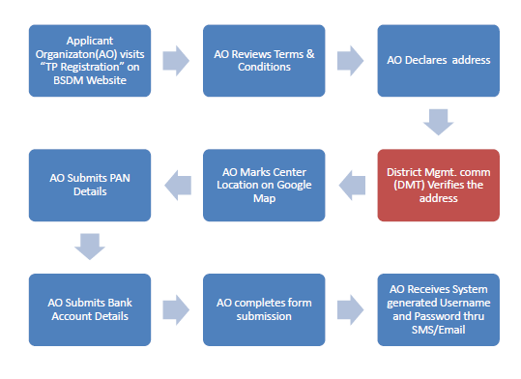

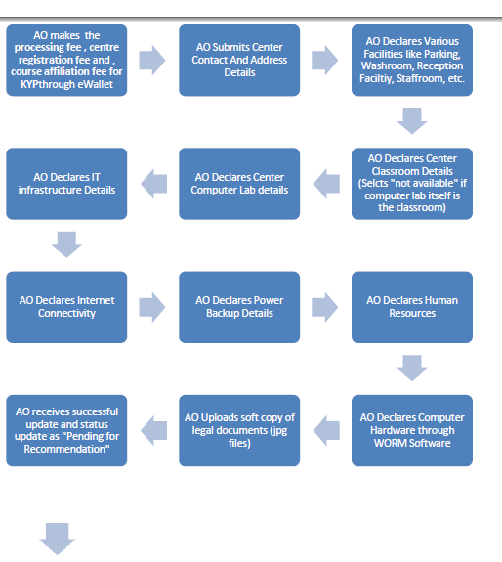
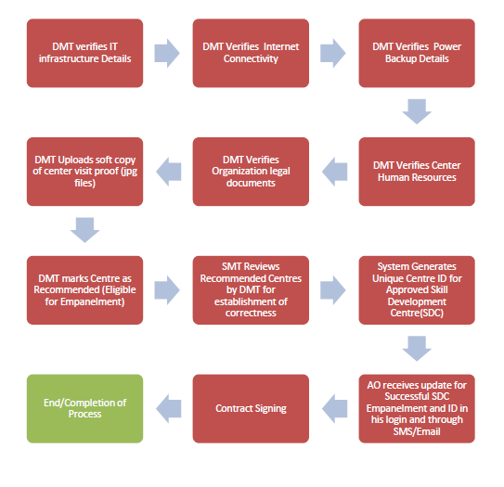
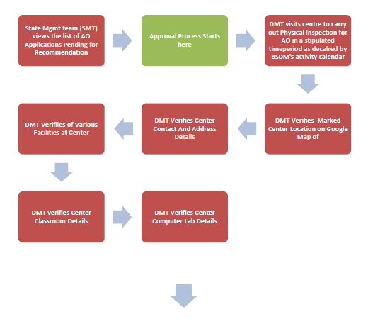

How to go on the SDC Registration page from BSDM Website:
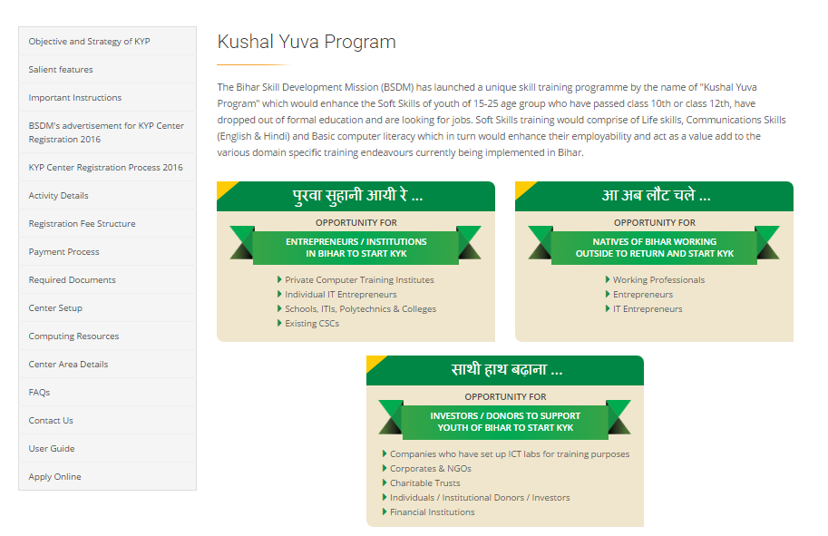
- Go to www.skillmissionbihar.org on any of the web browsers: Latest Versions of Google Chrome/Mozilla Firefox.
- Click on Kushal Yuva Program Tab on the website. Click on “Apply Online”
Click here
- There are three different links for three different types of Training Service Provider Applicants or Training Partner Applicant (TPA), interested in starting a Skill Development Center (SDC) under Kushal Yuva Program as shown: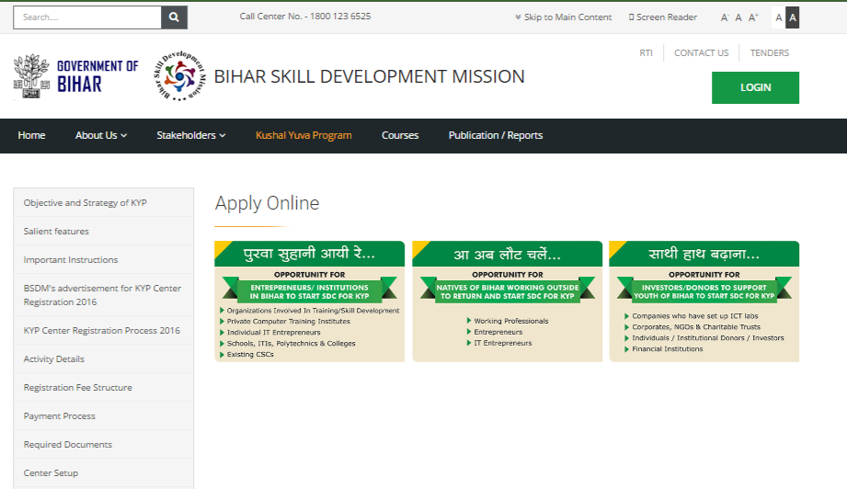

  - पुरवा सुहानी आयी रे...
If you are a local resident of Bihar State (an entrepreneur/institution) and wish to be a part of a new wave of Bihar’s progressive Development, and contribute in the same by starting your very own SDC, click on this image. This will open up the registration page for SDC for KYP:
Examples of Applicants under this category include:
- Private Computer Training Institutes
- Individual IT Entrepreneurs
- Schools, ITIs, Polytechnics, & Colleges
- Existing CSCs

  - आ अब लौट चलें...
If you are a citizen of Bihar, but working outside the state, and wish to come back and contribute in Government of Bihar’s revolutionary Skill Development Mission, and start an SDC for the same, click on the second image. A form like the following will open up to fill certain details and then the normal registration form shall open for filling.
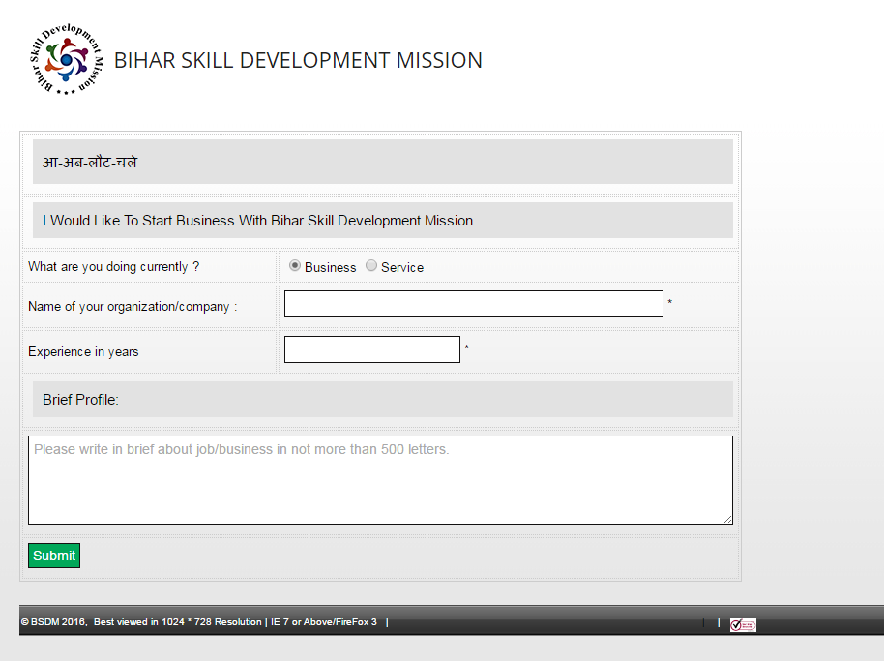
Examples of Applicants under this category include:
- Working Professionals
- Entrepreneurs
- IT Entrepreneurs
  - साथी हाथ बढाना...
If you are an investor or Donor, who are interested in contributing their funds to a needy Training Partner Applicant to start an SDC, click on the third image. A form like the following will open up to fill details of the TPA who shall be the Implementation Partner for this investor/donor. This type of Training Partner can provide details of whether the donation is in the form of funds or IT Infrastructure/entire Lab for the SDC.
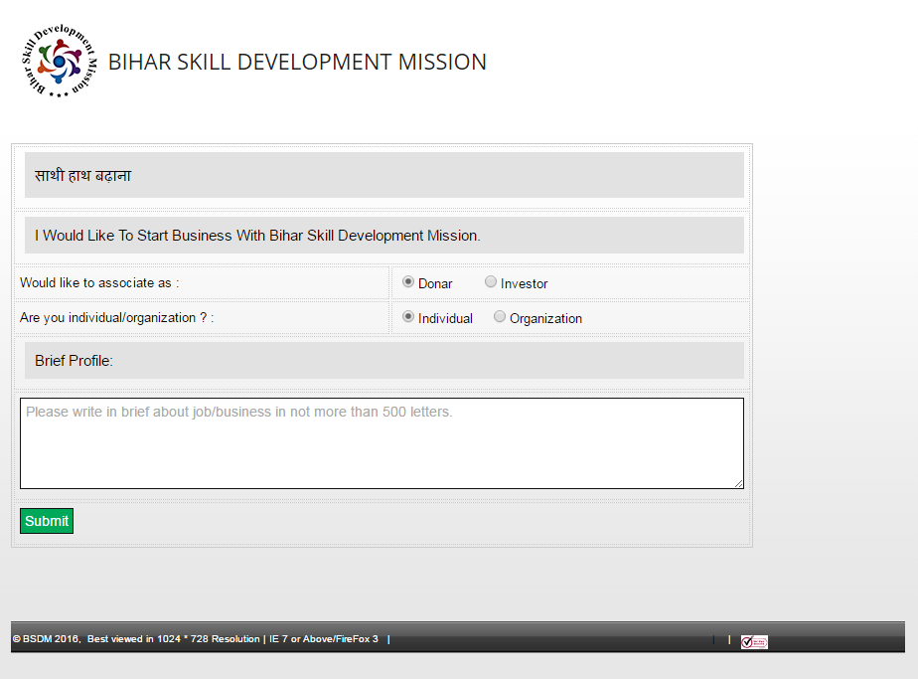Examples of Applicants under this category include:
- Companies who have set up ICT Labs
- Corporates and NGOs
- Charitable Trusts
- Individuals/Institutional Donors/Investors
- Financial Institutions

- Click on ‘पुरवा सुहानी आयी रे…’ link. You shall be redirected to SDC Registration page:

Steps for Applying Online for SDC Registration:

Step 1: Review of Terms and Conditions:
- Enter all the required details in the above form related to your organization/individual details.
- Enter the choice for your Identity Proof.
- Enter Details of the Identity Proof Document
Click on and browse through your files. Upload the PAN Card scanned Image by clicking ‘Upload Image’.
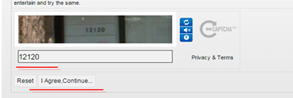

- Fill the remaining details and click on I agree, continue (for terms and Conditions mentioned)
- Your application is submitted to BSDM, and activation link is mailed to your mail id. Also You shall receive the DMT assigned for you for approval and other coordination.

- Click on activation link (marked in below image – red box) to validate your email account. Also, you will receive one mobile secret code or OTP (One time password) to validate your mobile number.
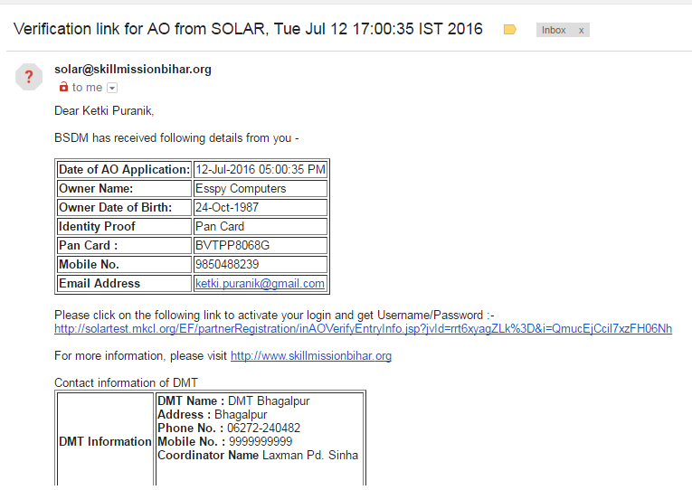

- After validating your email account you will receive another mail from BSDM with your login ID and password.
- Login your Email Account and check your email and go to the link mentioned in the mail.

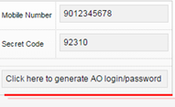
- Enter Your Mobile Number and your mobile Secret Code.
- And click on “Click here to generate Application Organization (AO) login/password”. Congratulations!!! Your BSDM login is generated successfully.

- Click on the URL above and Enter Username and Password in the areas.

- A screen opens up to change your password.
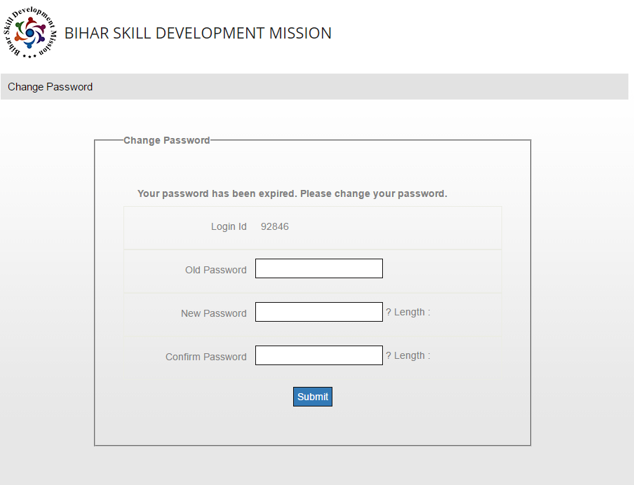
- Enter Old Password and New Password (twice) and Click on Submit.
- Following email with new changed password details will be received:
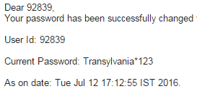
- Now Login with updated password on the URL in the earlier mail (Login Generation Mail). Following screen will appear:
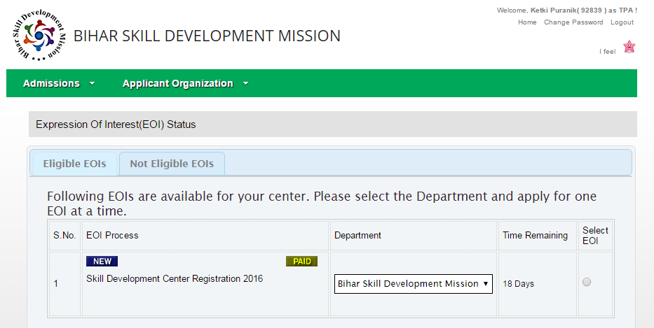
Click Here

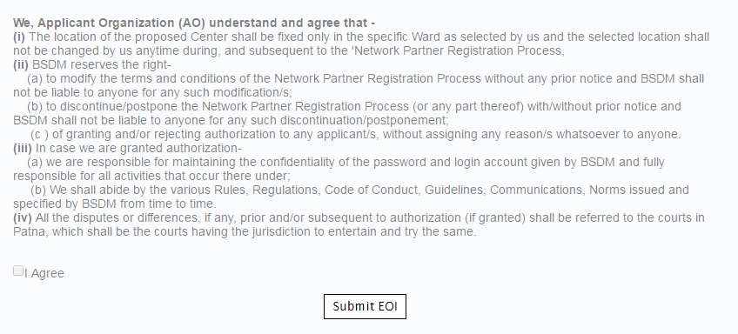
Agree to the Terms and Conditions

Click Here

- Click on “Select EOI” and check on “I Agree” to the Terms and Conditions and click on “Submit EOI”. On the pop-up message “EOI Successfully Applied”, Click “OK”.
- Click on Applicant Organization View EOI Status
- You shall see the status of the EOI as “Review Terms and Conditions”.
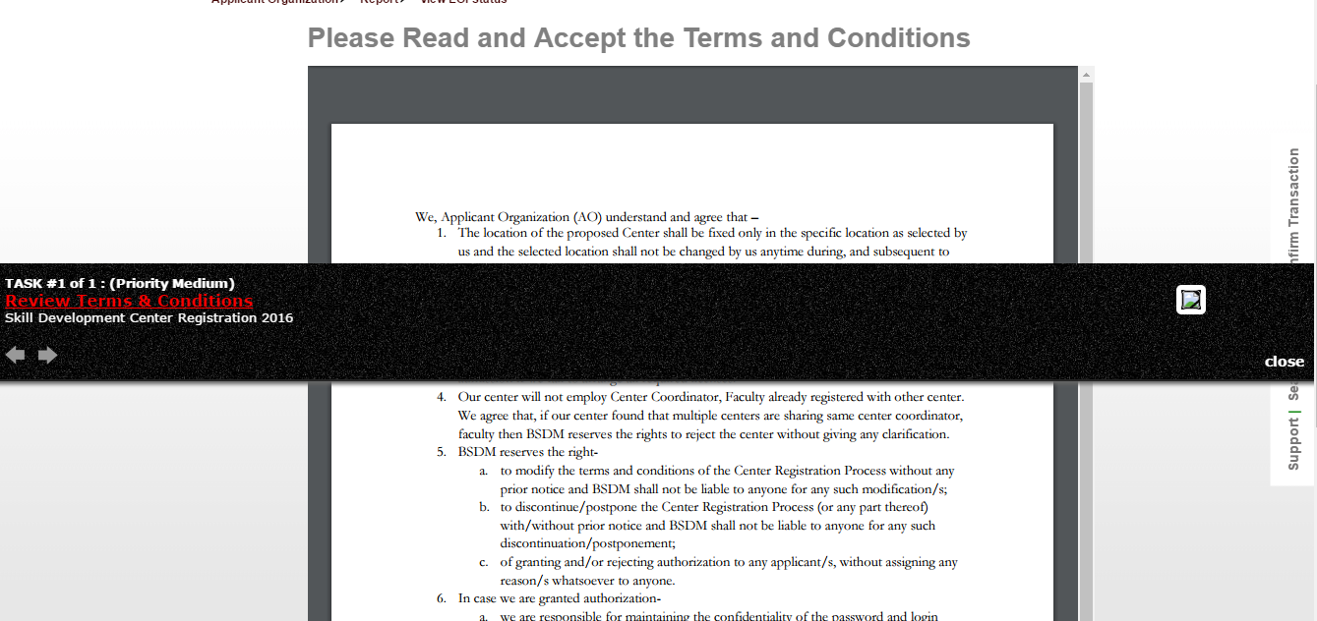

- Click on “Agree”.

Step 2: Declaration of Address
- Now View EOI status will show the following: “Declare Address”
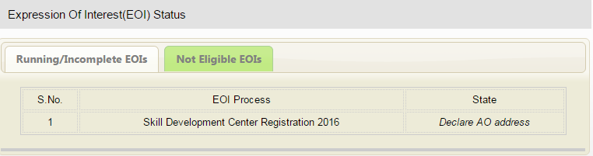
Click Here

- Click on the Link of Declare Address and a Detailed form shall open up for filling Location Details for the aspiring SDC:
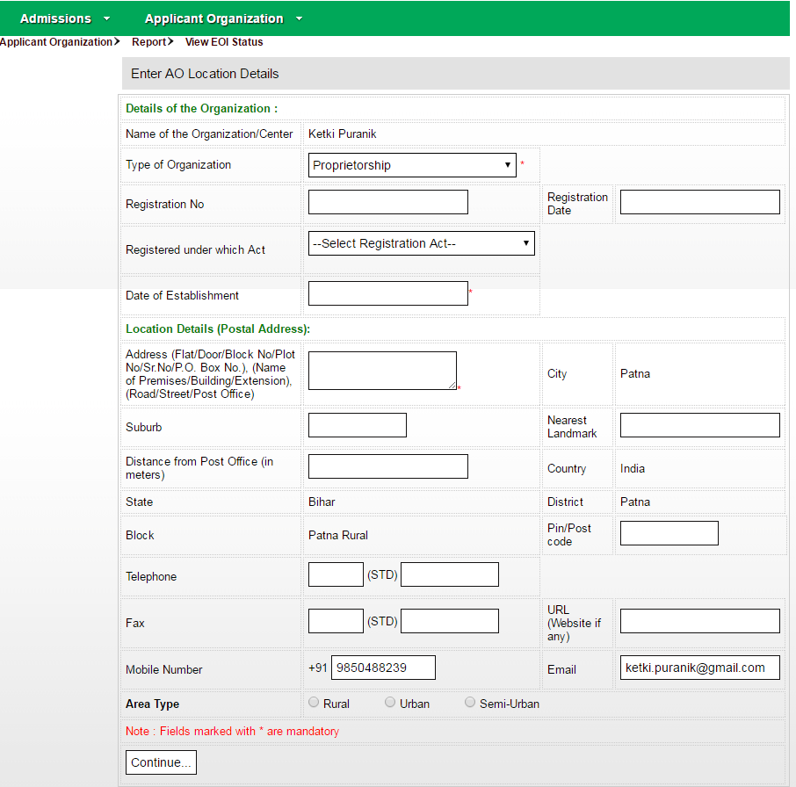
- Fill all the Details in the form and click on “Continue”. A report with the filled details will come up with the entered details. If the details are correct, click “Submit” or else click “Back” and edit the information.

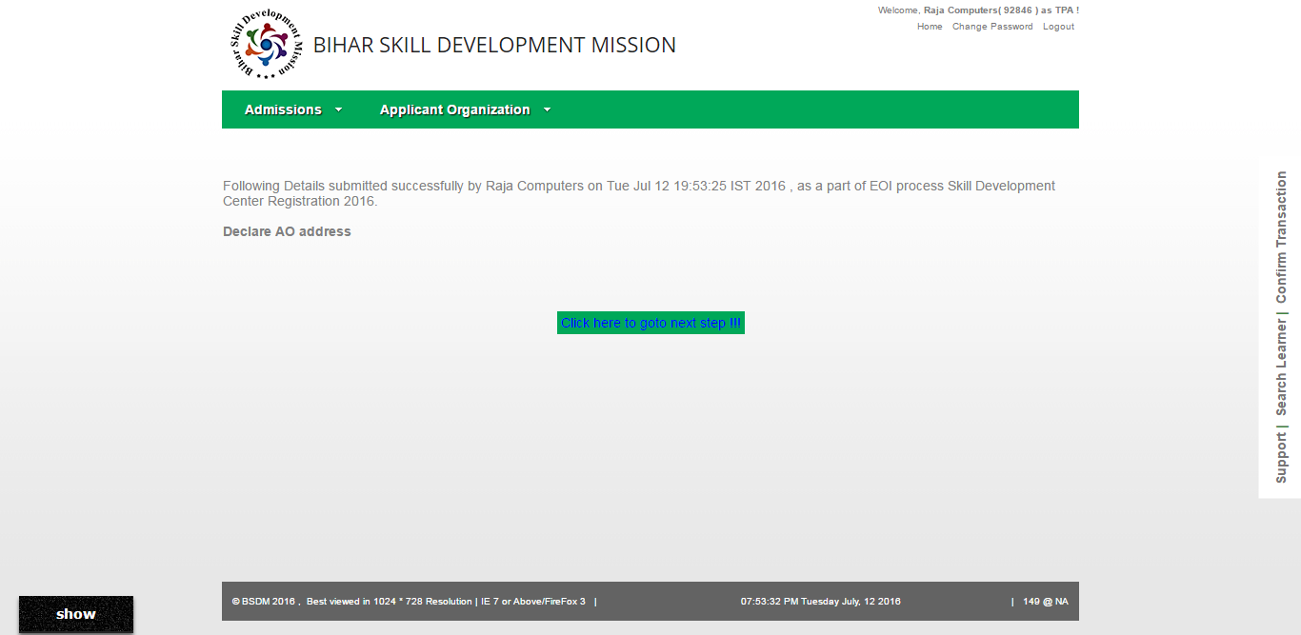
Click Here

- Information is now saved successfully (A message pops up with this text). To go further, Click on “Click Here to go on next page”

Step 3: Verification of Address by DMT
- Now the EOI Status is “Verification of Address by DMT”. Now DMT shall approve the address as entered by you from their login. Please await a status update regarding address verification in your email. The assigned DMT can be contacted for information in this respect.
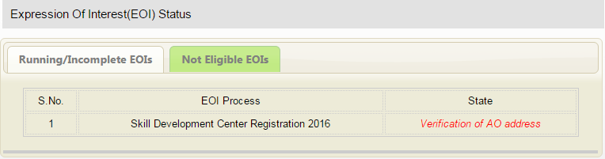

Step 4: Mark Center Location on Google Map.
- After Approval of address by DMT, the EOI Status (Update received in Email), the Status of EOI in your login shall be: Mark Center Location on Google Map. Click on that link and the following page will open up with Google Map marker. Drag the location to appropriate location:
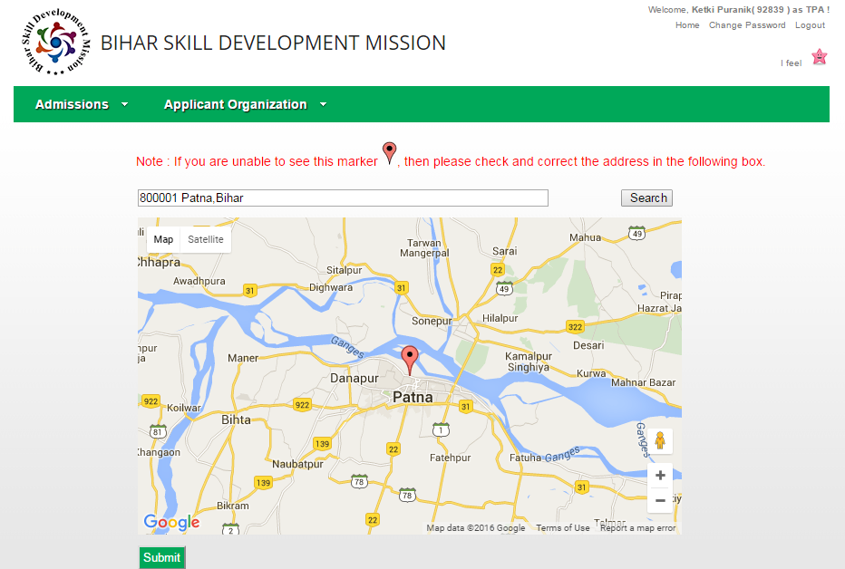
Click on Submit.

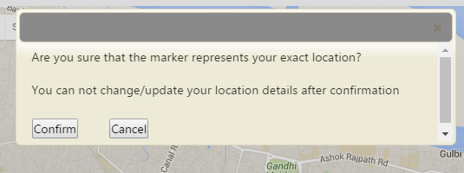

- Click on “Confirm” if dragged location is correct, or else click on Cancel and remark the location.

Step 5: Submission of PAN Details
- Now after going to next page (Click here to goto next page), the EOI status is Submit PAN Details.

- Click on the link and submit PAN Details in the form the opens up:
PAN Card Details
PAN Card No. | * | Confirm PAN No. | *
PAN Card Holder Name |  | *
PAN Card Type |  | Individual Non-Individual *
Father's Name |  | *
Date Of Birth
Click on Submit. After receiving successful message, click on the next page link. The Page will now say: Bank Account Details not filled. Click on Click here to Enter Bank Account Details.

Step 6: Enter Bank Account Details

- Enter the bank account details in the page that open up and also click on to upload cancelled cheque scanned copy.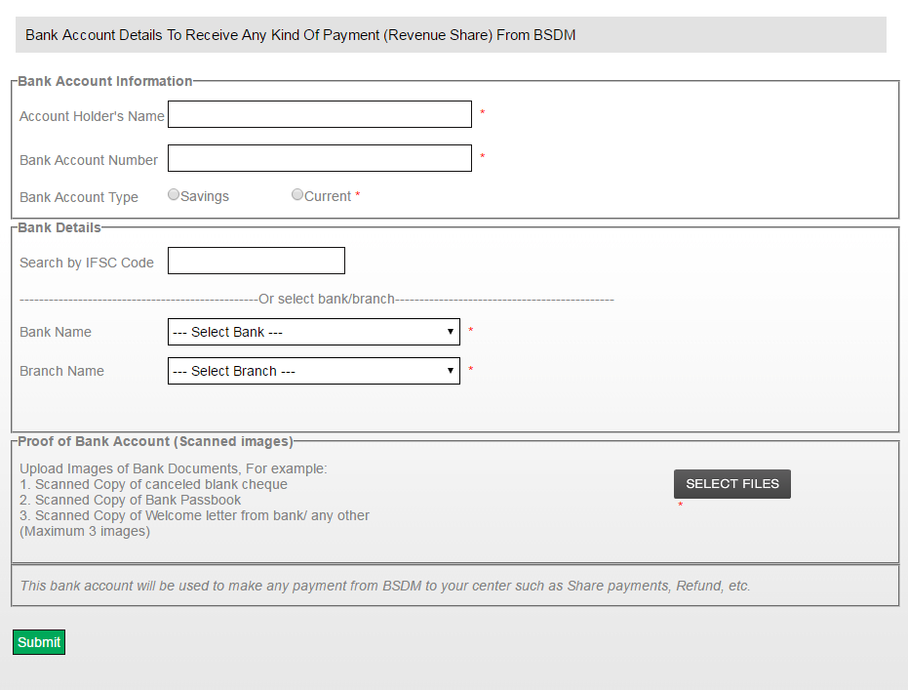
Enter Account and Bank Details
Click on Submit
Upload Cancelled Cheque Scanned image

- This bank account will be used to make any payment from BSDM to your center such as Share payments, Refund, etc.

- After entering the bank account details and submitting, the message “Bank Account Details saved successfully” appears.

- Now the EOI status remains “Submit Bank Account Details”. Click on the link and following report showing awaiting verification statuses of the documents attached and submitted:
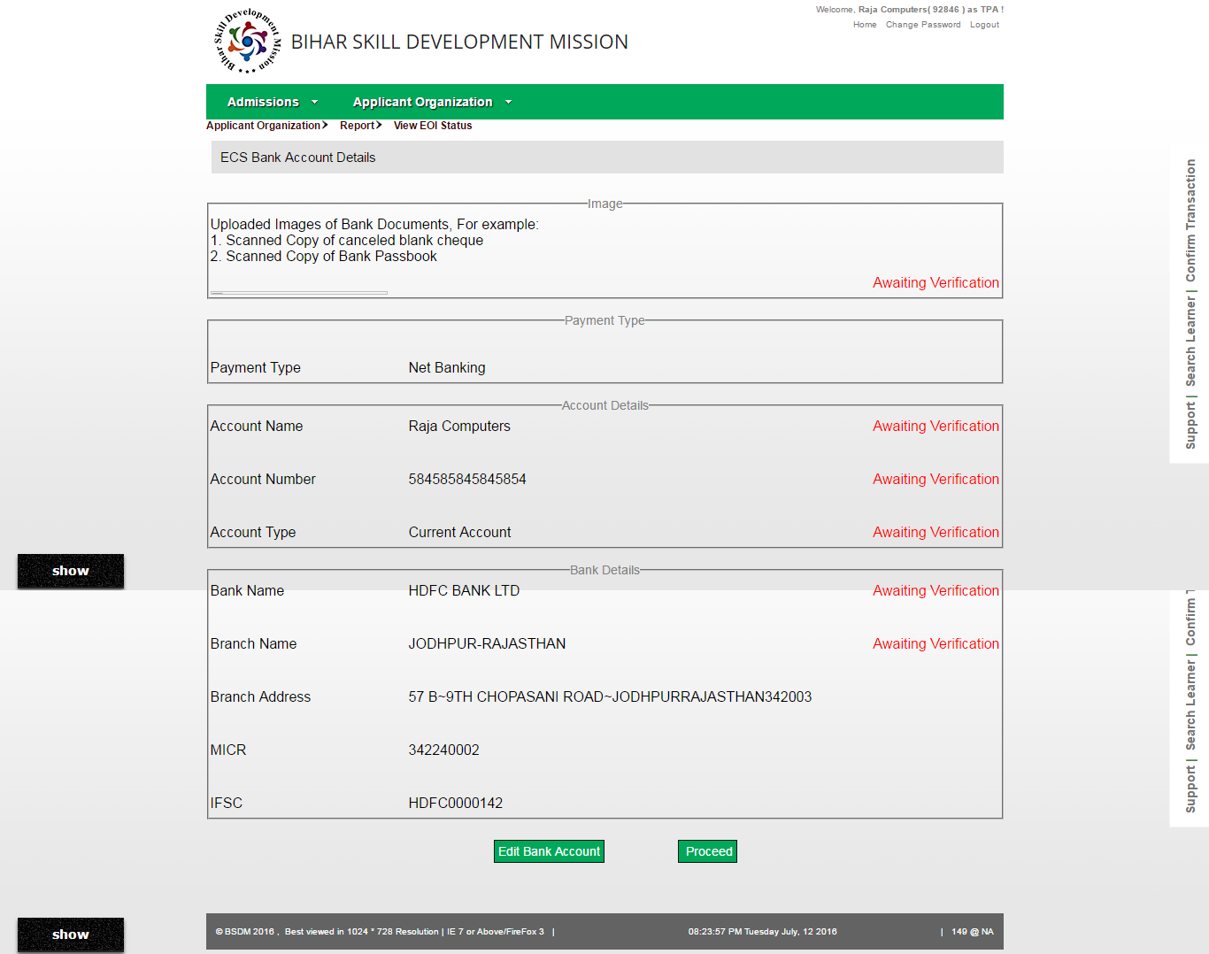
Here you can verify and edit the bank account details before clicking Proceed.
The message of record saved successfully appears and now click on the link going to next page: Click here to goto next page.

Step 7: Making Processing Fee, Center Registration Fee and Course Affiliation Fee Payment
- Now the EOI Status is “Make EOI Payment”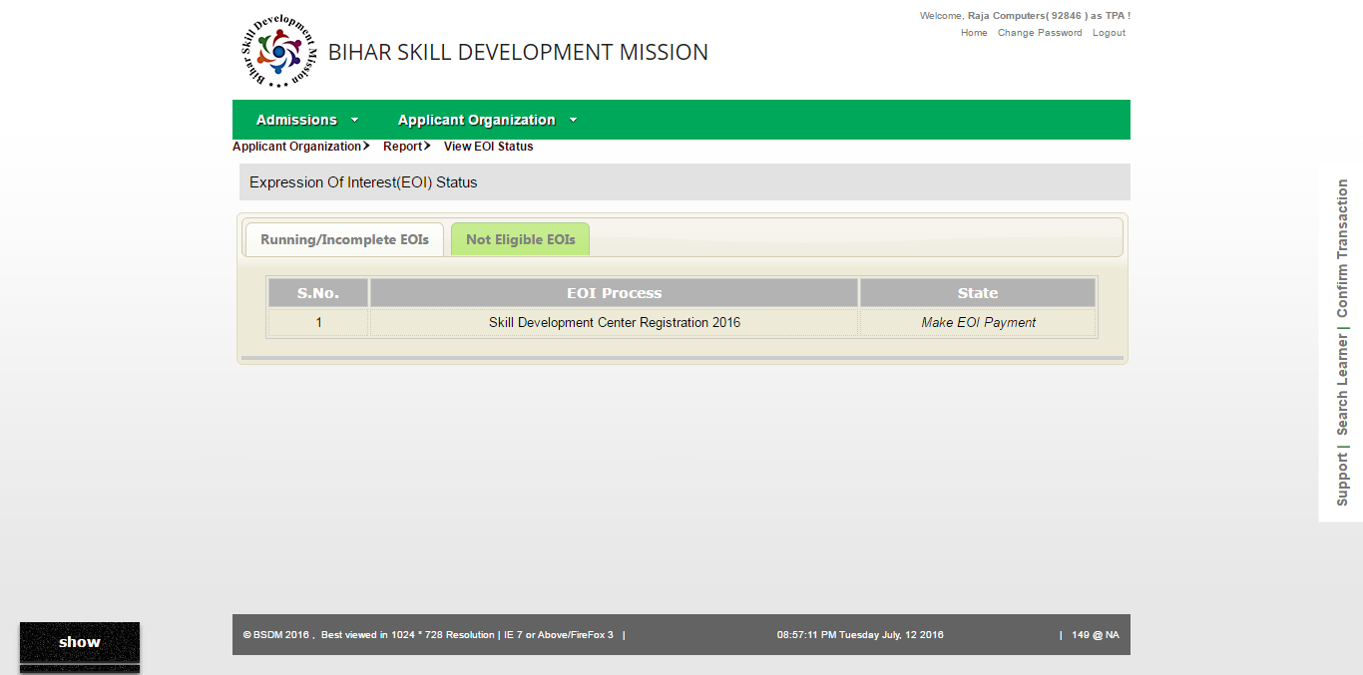
- Click on that link for making payment.
- Cash Payment mode is selected. The processing fee amount is displayed.
- To generate challan click on the link and print it for your reference to be submitted at the bank.
- Cheque/DD:
  - Click on the mode from the left hand side menu.
  - Enter the Drawer and Drawee Details, Date and Cheque number in the appropriate areas
  - Click Submit after viewing the amount for which cheque/DD is to be given
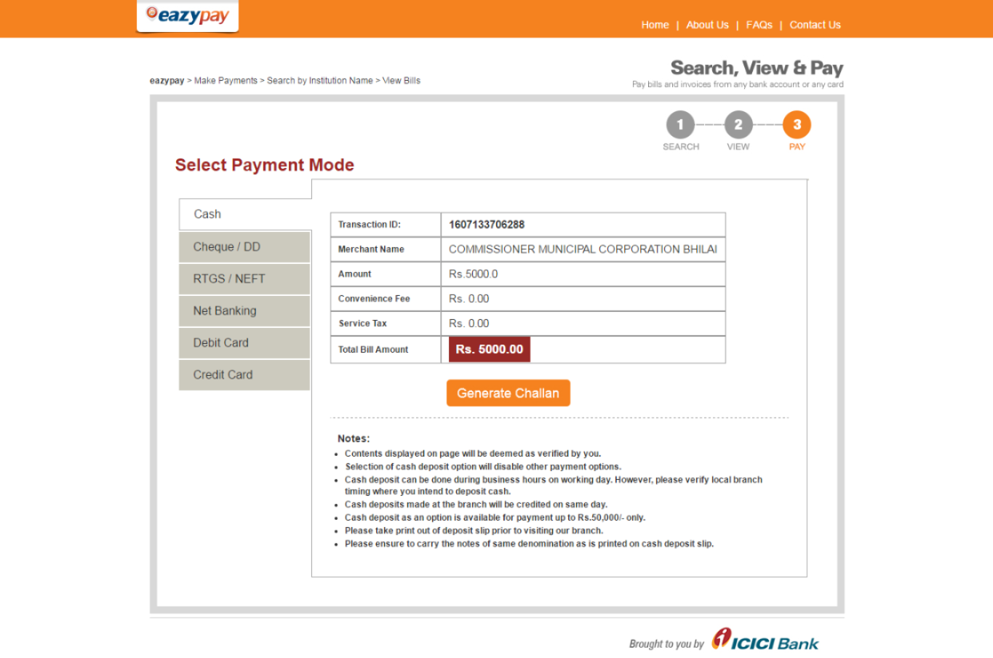
  - To generate challan click on the link and print it for your reference to be submitted at the bank
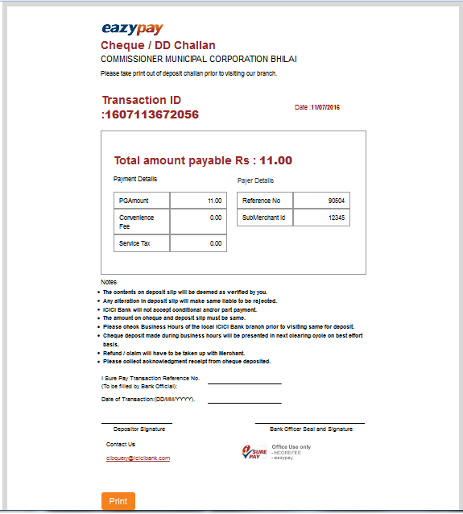

- Above is the Challan Generated after filling the cheque details. This is to be produced at the bank with the cheque.
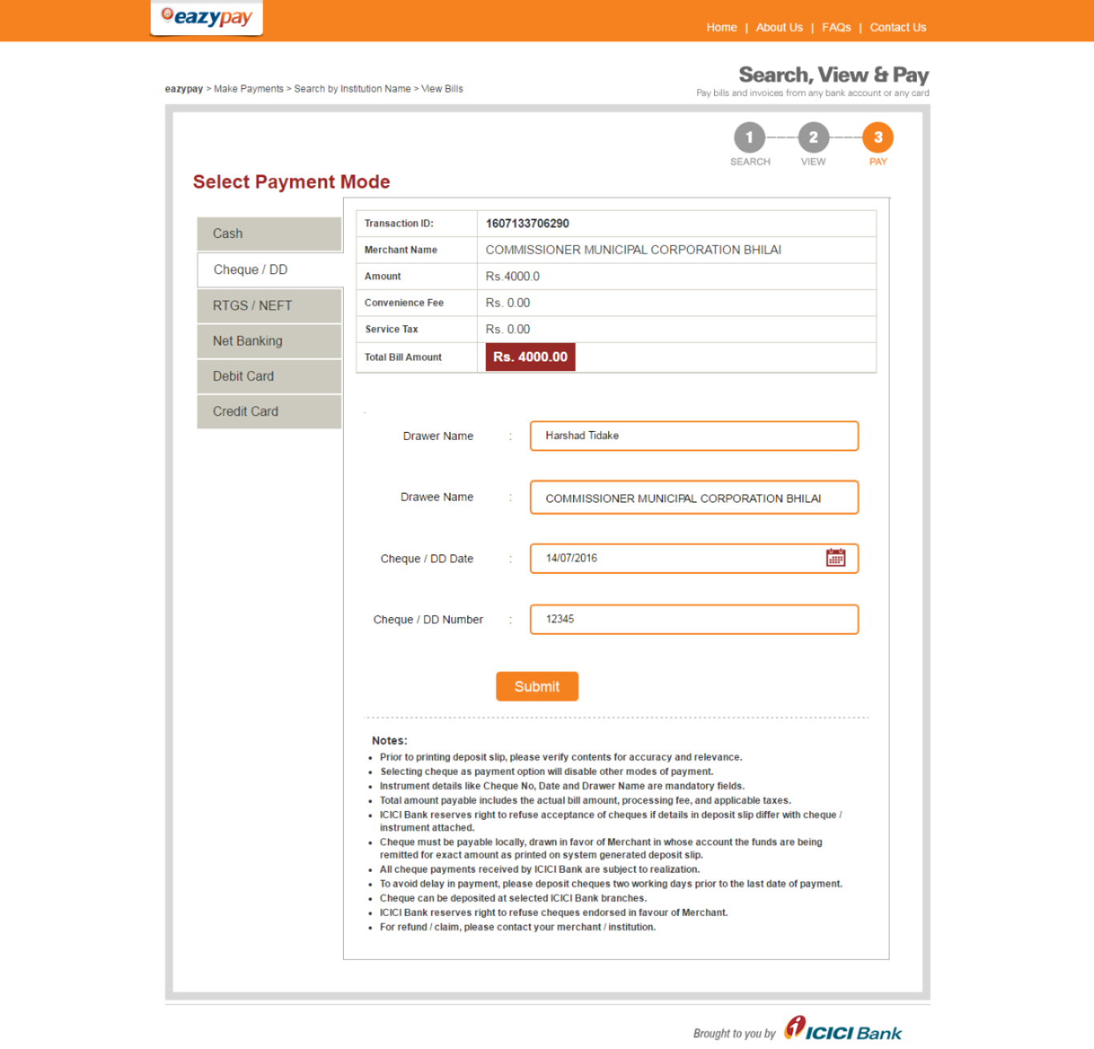
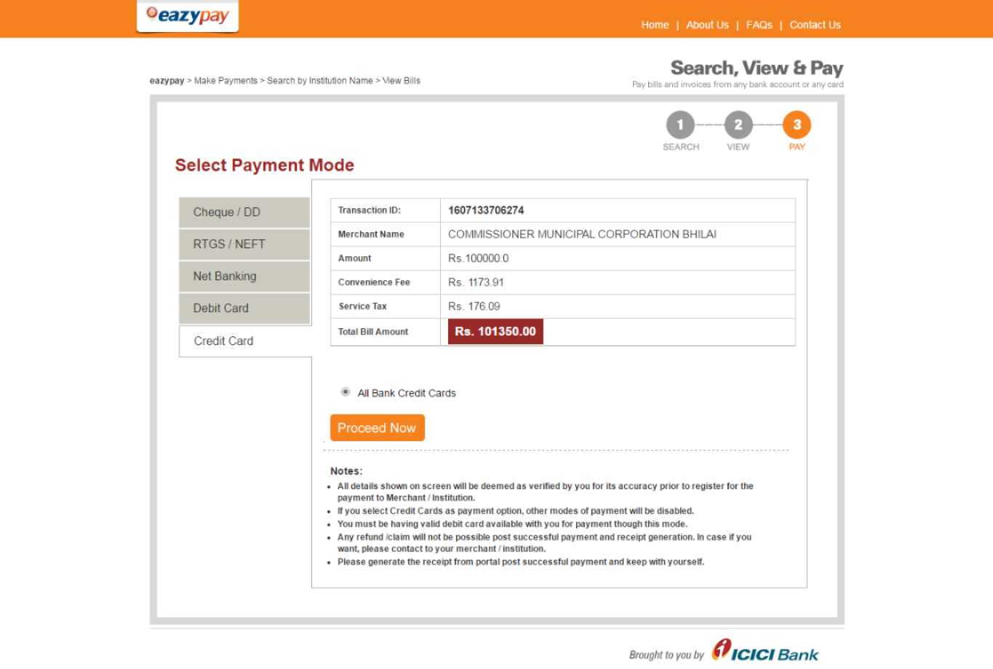
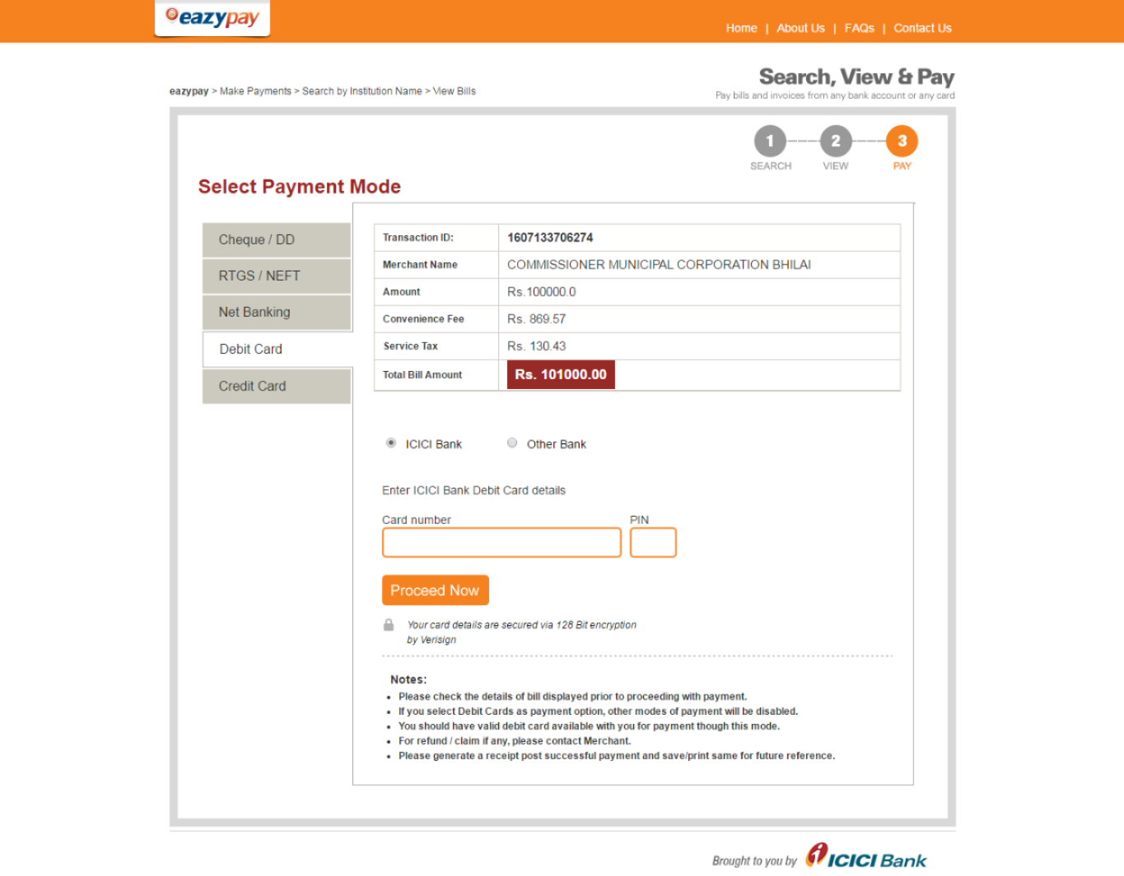
- Above shows the Debit card method of payment, here please enter the Debit Card Number an PIN. Click Proceed Now .
- Similarly for Net Banking Mode, Enter the Following Details:
  - Prerequisite: Payer should have an account with the Bank and net banking facility should be made available
  - After clicking on Net banking mode please select bank
  - You shall be redirected to the net banking login page of the respective banck
  - Log in with you net banking username and password
  - Verify the amount to be transacted
  - Answer securuty Questions or enter the One Time Password (sent on the phone) to authenticate Transaction
  - You shall get a message of ‘Transaction is complete”
- For RTGS/NEFT,
  - select the Bank
  - Enter the IFSC Code of the Bank
  - Enter the Account Number and name of the recepient (BSDM)
  - Verify the entered details
  - Generate Challan to be given at the bank for processing transaction

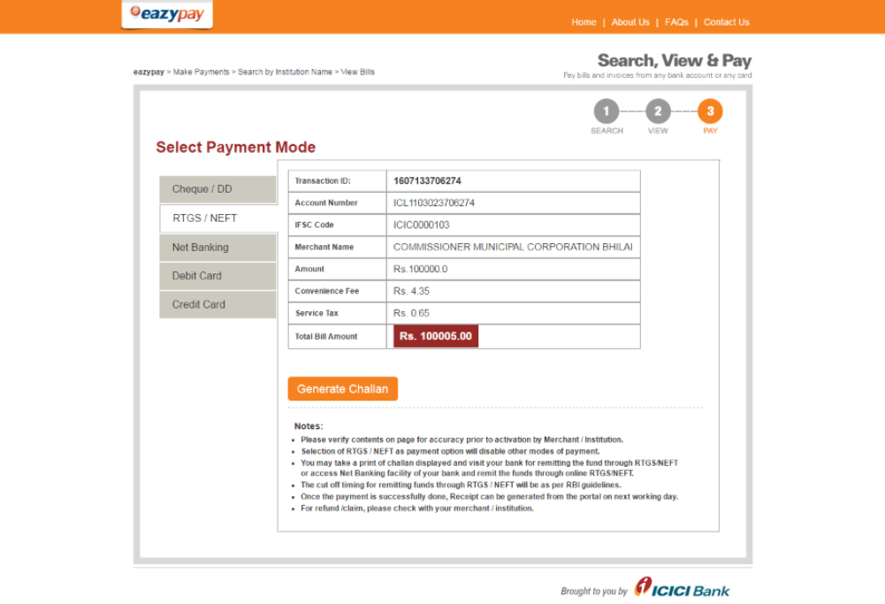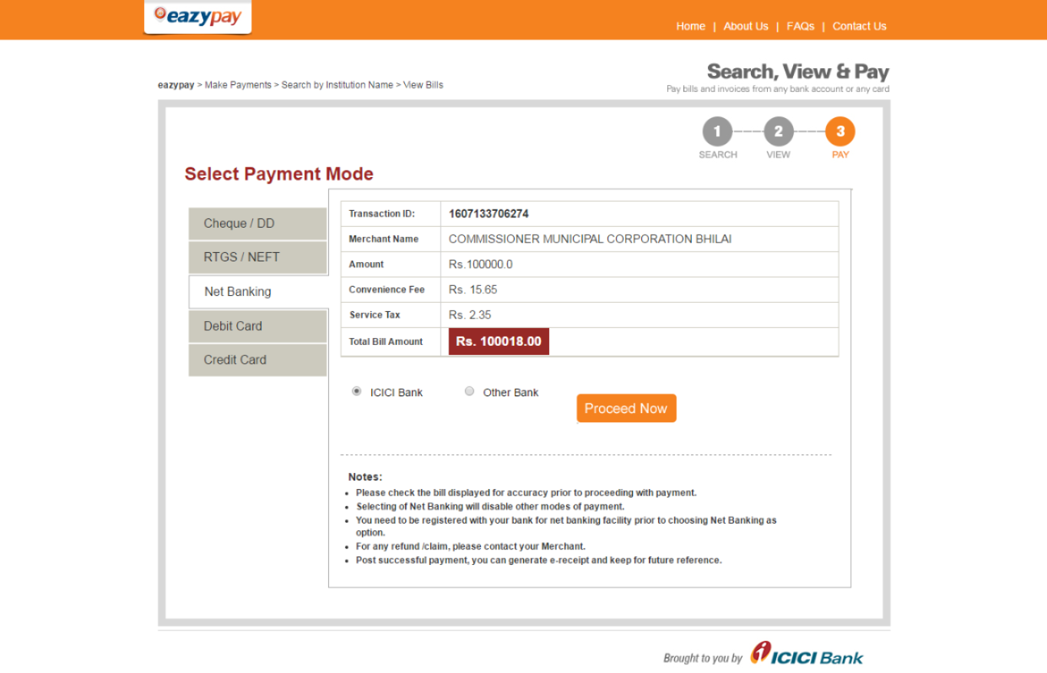

Step 8: Submission of Center Contact and Address Details
- After making successful payment, the next status is: “Submit Center Contact and Address Details”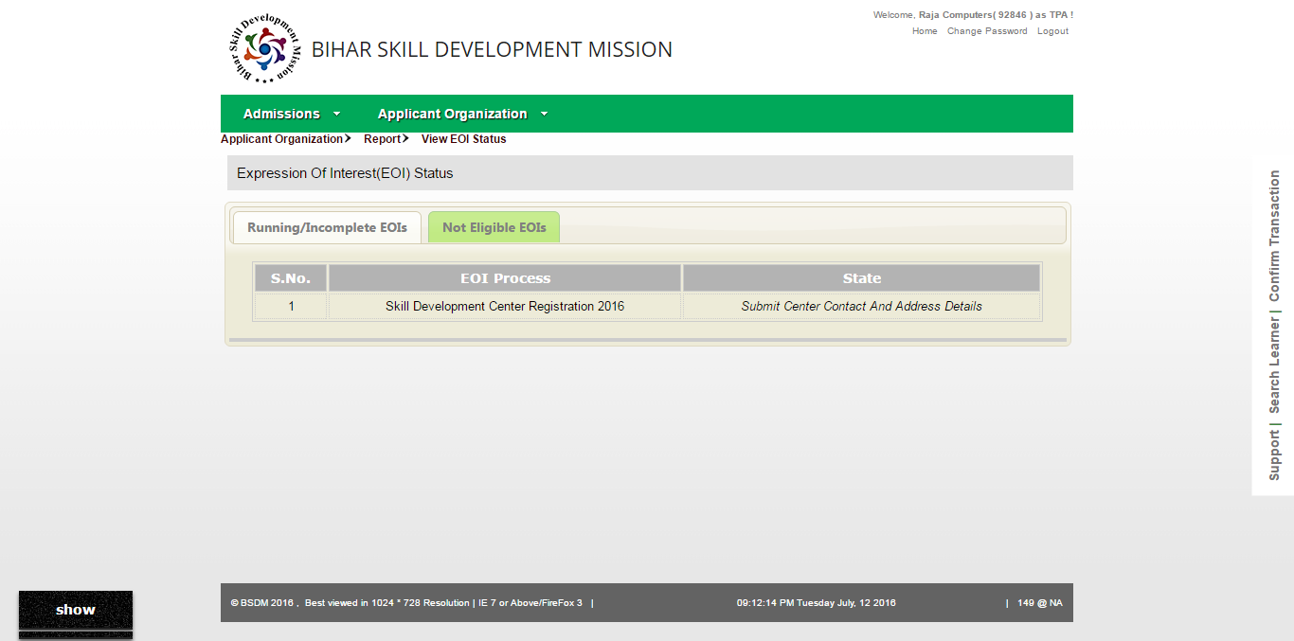 Click on that Link. Following Form Appears: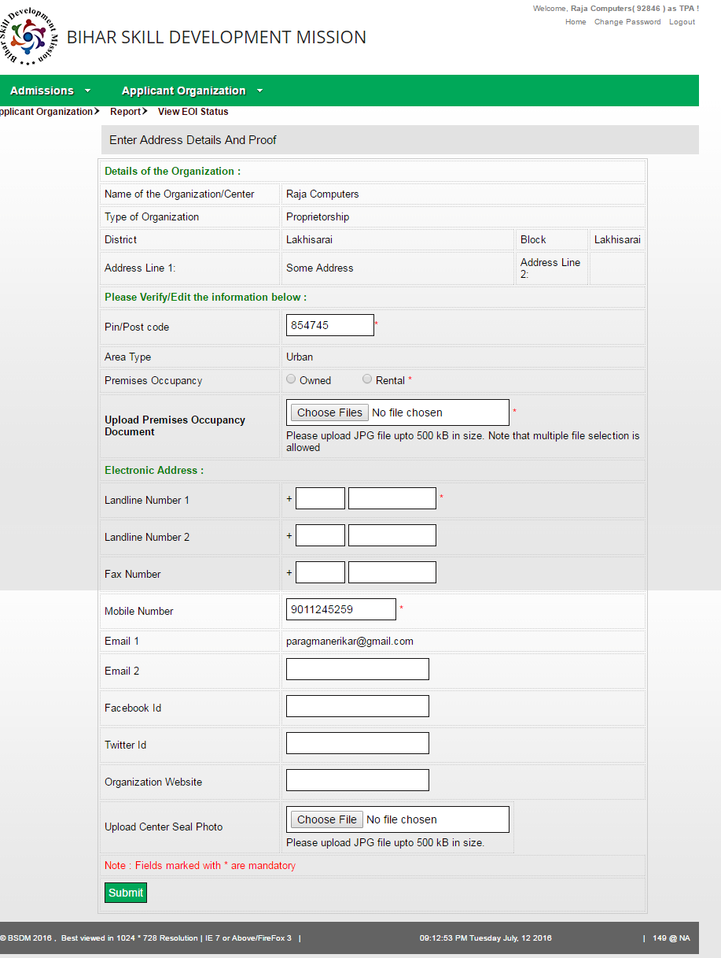
Click Here

- Fill the necessary Details. Following Uploads are required:
- Premises Occupancy Document : Click on “Choose Files” Button. Multiple files can be selected for uploading upto 500KB size
- Center Seal Photo
- After making necessary entry in the form, click on “Submit”. Now The message of record saved successfully appears and now click on the link going to next page: Click here to goto next page.

Step 9: Declare Premises Infrastructure Details
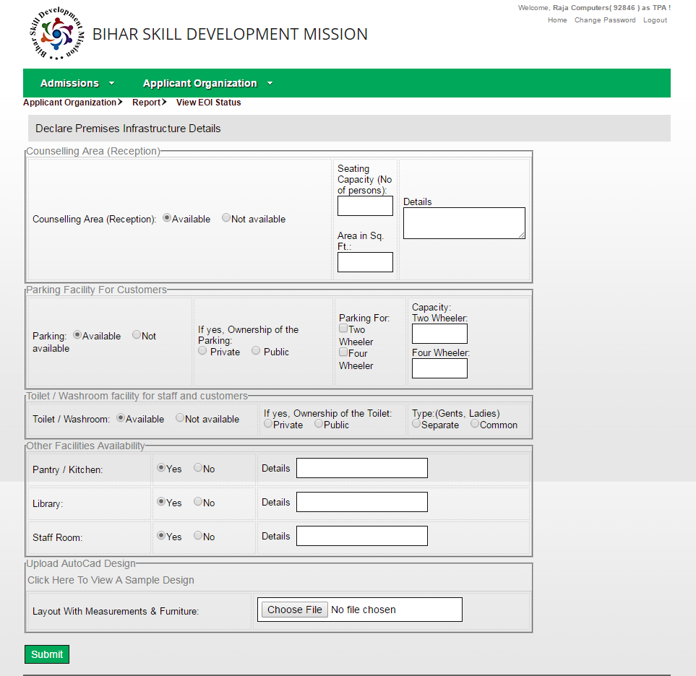
- The EOI Status is now “Declare Premises Infrastructure Details”. Click on that link. The following form appears:

Fill the necessary Details. Following Uploads are required:
- AutoCad Design for Layout with measurements and furniture.
- Here the facilities for the centre are required to be entered, like furniture, Parking Facility, Washroom Facility, etc.
- After uploading the necessary details, the stage of Declaring Various Facilities is completed. Now on next page, the message appears as following so as to declare Classroom Details.
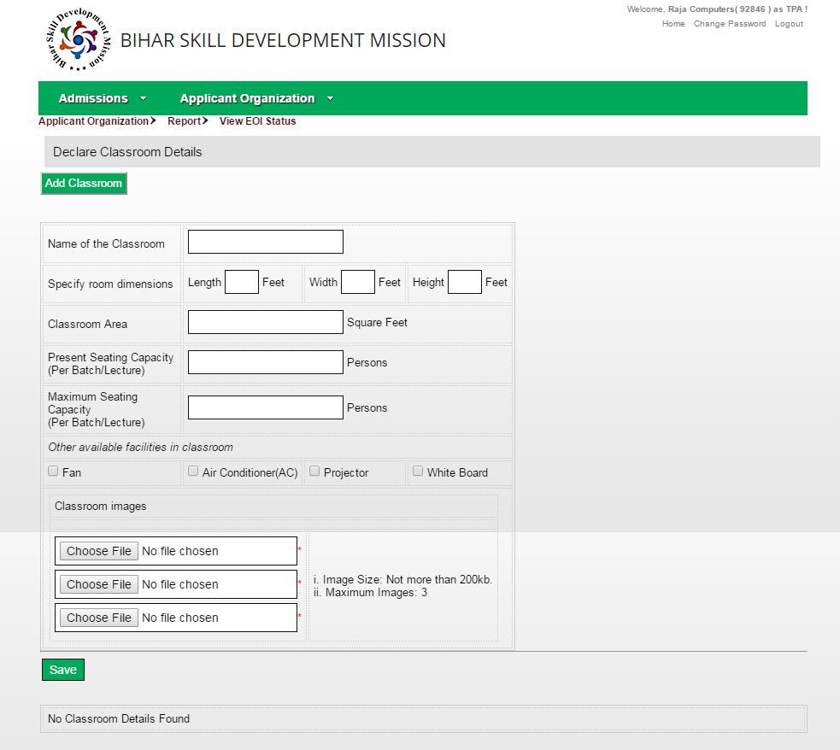

If Centre is going to have a separate classroom and Computer Lab ; or as a single unit (Lab cum Classroom) is to be filled by the Applicant in the above form.
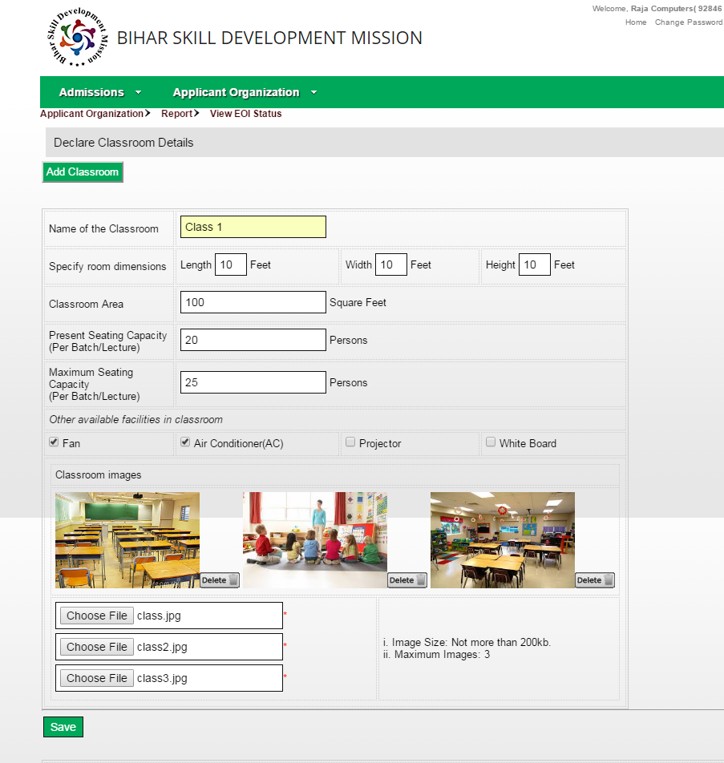
- Here the Applicant is required to fill the dimensions, name,, Capacity details of the classroom at the centre. Here the centre classroom images are to be uploaded by clicking on “Choose File”. After filling necessary details, click on “Save”.
Once these details are saved, a page appears with facility to add more classrooms:

- If you have more than one classroom, click on “Add Classroom”, or else click “Save and Continue”. After saving each classroom a list appears as Class 1, Class 2 and so on. The approval of this is pending at DMT login, but the “View-Confirm” Button shall ensure your entry is correct. Click on View-Confirm or to edit the details, click on “Edit”, make changes and after saving, Click on “Save and Continue”.
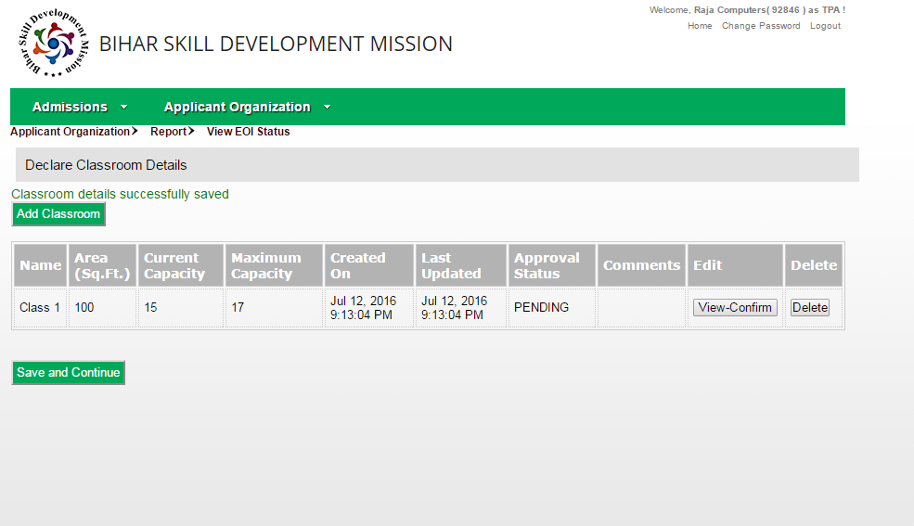

Step 10: Declare Center Computer Lab Details
- Now the EOI status is “Declare Center Computer Lab Details”. This I the case when Classroom and Lab are separate.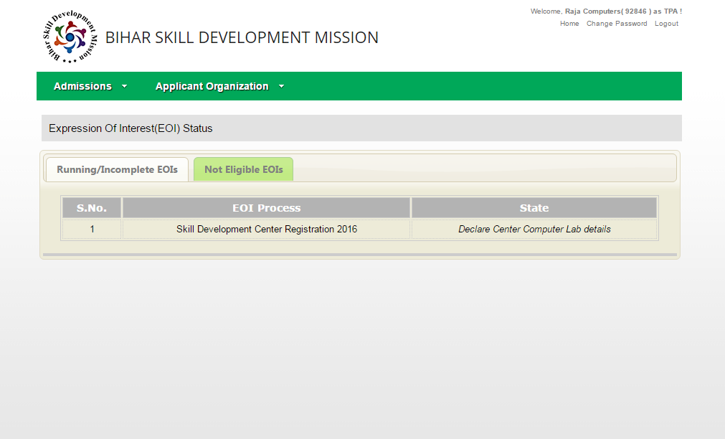
Click on the link to fill the firm for Lab Details, just like Classroom Details as follows and after uploading images and entering the dimension details and computer count, click on submit.
Note: Minimum Computer count required is 20 and maximum is 30.
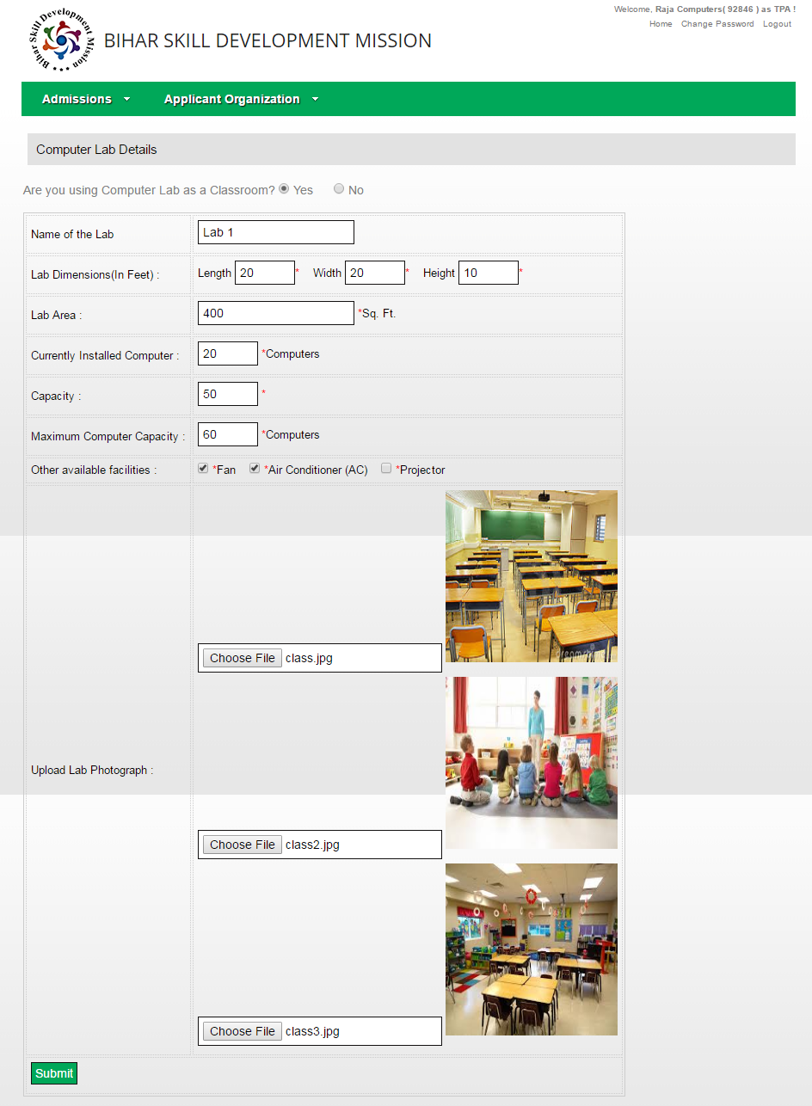

Step 11: Declare IT Peripherals
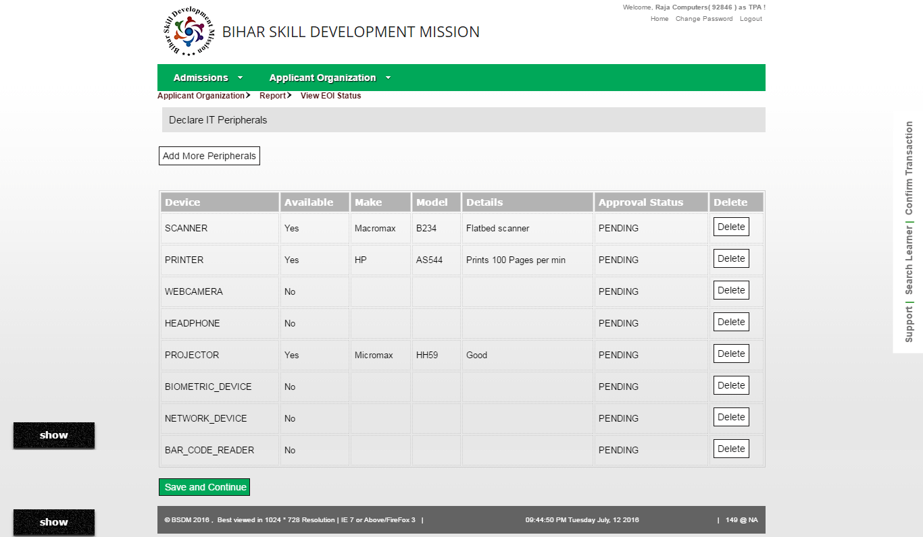
- The next step is to “Declare IT Peripherals” like scanner, printer, webcam etc. in the following form:
Click on “Add More peripherals” to do so. If details are correct, click on “Save and Continue”
- The next step is to specify internet set up at the centre. (Click on View EOI Status under Applicant Organization to view the details pending to be filled from time to ime.)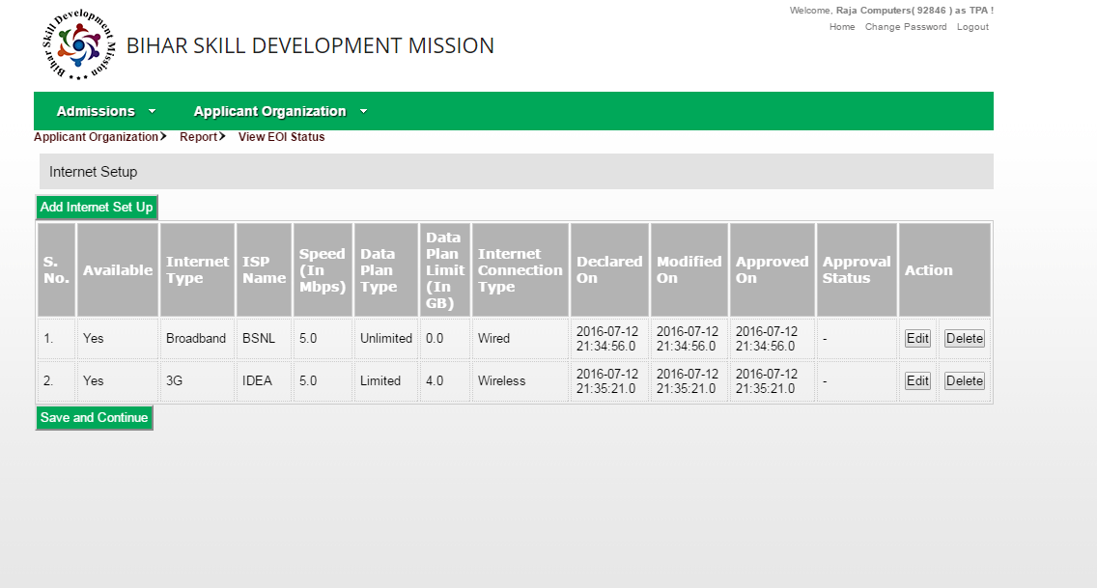
Click Edit to make changes in the internet setup details. To add more setup click on “Add Internet Setup”. To Finish, click on Save and Continue.

Step 12: Power Backup Details
- The next step is to specify Power Backup Details at the centre. (Click on View EOI Status under Applicant Organization to view the details pending to be filled from time to time)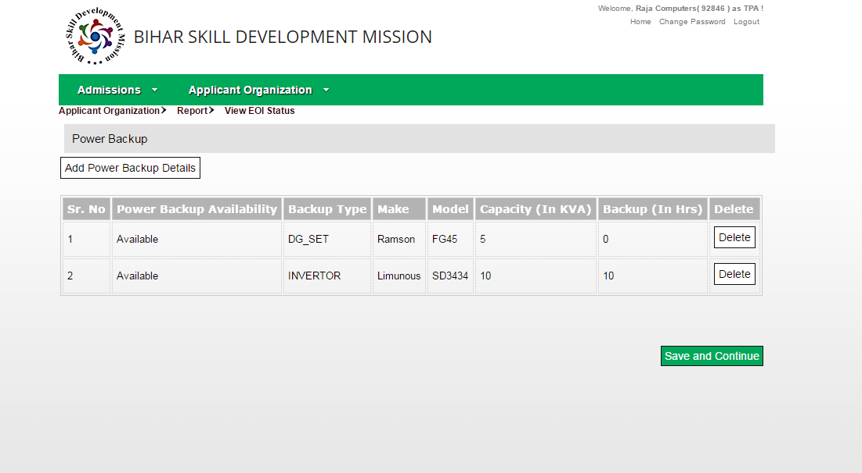
To finish, click on Save and Continue.

Step 13: Declare Human Resources
- Now the EOI status is “Declare Human Resources” as can be seen under the “View EOI Status” menu. Click on the link and the following form opens: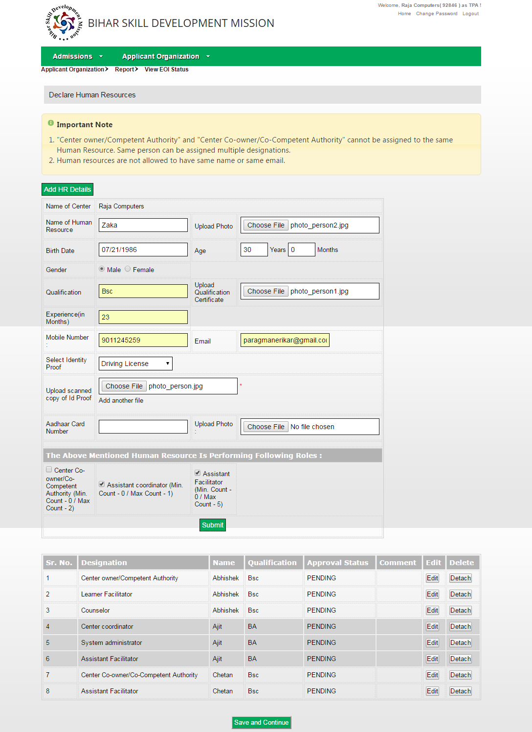
- Enter the required details like Name, Photo, ID Proof , Role Performed. It is important that Centre owner role nd centre co-owner role cannot be assigned to the same person. After entering the details, click on Submit. To add more resurces, click on “Add HR Details”. After submitting HR details click on “Save and Continue” to complete the this process. A list of added HR details is shown for verification.

Step 14: Declare Hardware and Software Details
- Now so that the District/State Management Team can approve remotely the centre for various softwares downloaded for the purpose of Skill training and also th monitr remotely the Computer Configuration/Soecifications, it is necessary for the Applicant Organization to click on Hardware declaration using Worm Software link in the latest View EOI Status.
- Following Screen appears on clicking the link: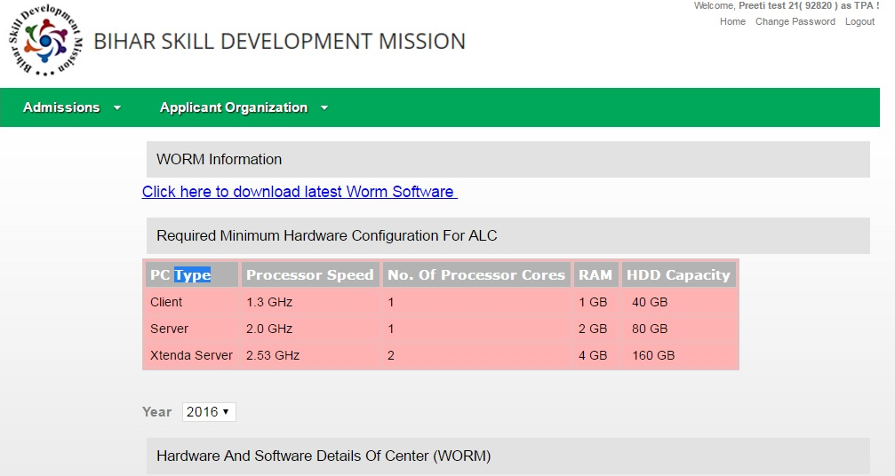
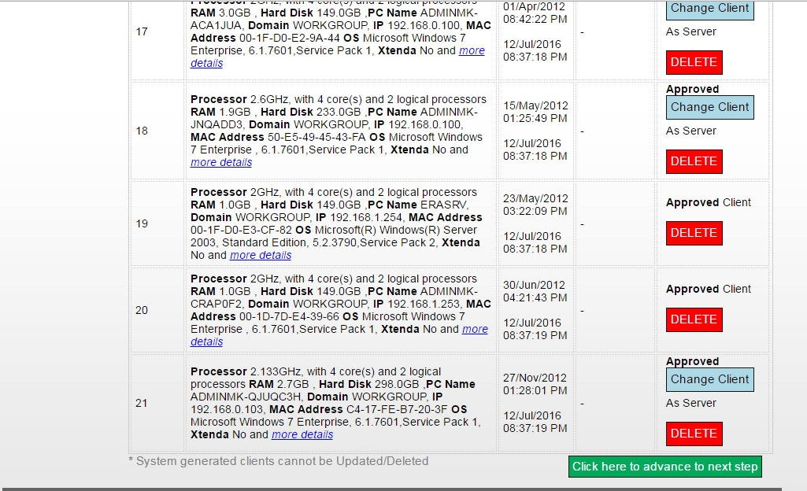

- Please follow the following steps:
- Install the WORM Software on your server & client machines
- WORM software detects all the configuration details of all the machines connected in same LAN network in your center
- Upload the these details on SOLAR from the WORM software

- Once you upload these details, you will see these details in your SOLAR login at the same link (as shown above)
- You can view all the machines uploaded through WORM
- You have to mark them as Server/Client and submit
- Once you submit details for all the machines, kindly click on “Advance to Next Level “Button in the bottom
- If you are having any problem in using WORM Software, contact your DMT Coordinator immediately for required help.

Step 15: Upload soft copy of legal documents
- Now the EOI Status is “Upload soft copy of legal documents”. Click on the link and the form opens:
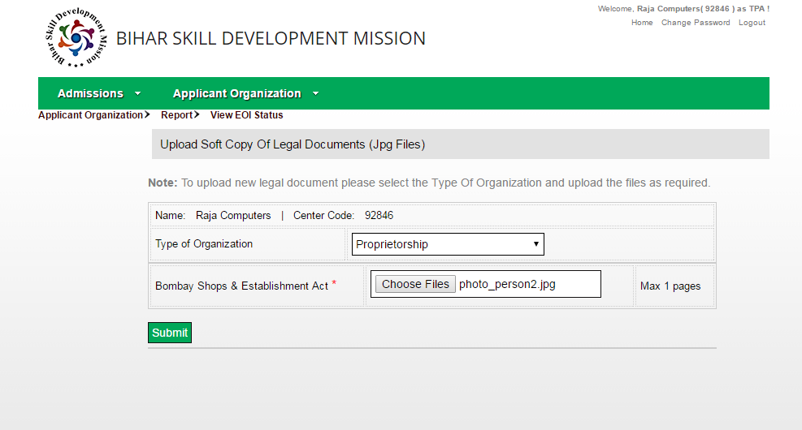

Upload the JPG format file of the legal document by clicking on Choose Files. Click Submit.
- After completion of this step the status of EOI becomes red in colour; Status being: Verification of Marked Centre Location on Google Map”.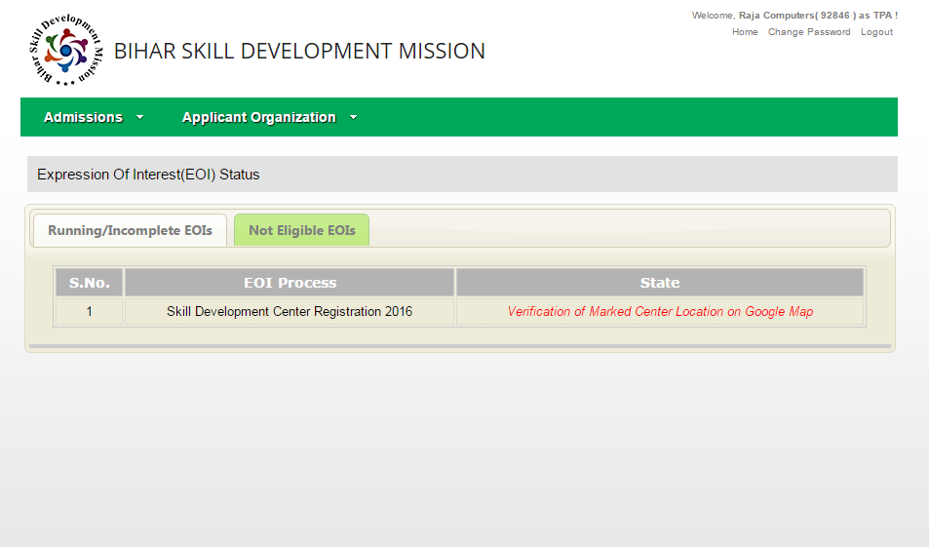

DMT Verification and Completion:
Once you complete all the above steps, you have completed all the steps from your side. Further steps are verification steps which would be completed by your respective DMTs. Following verifications are done by the DMT in their login. Regular updates are received on AO’s email on approvals:
- Verification of Organization legal documents:
  - DMT will verify and approve Organisation Legal Documents uploaded by AO
- Verification of Address Proof:
  - DMT will verify and approve Address Proof Documents uploaded by AO
- DMT Approval - Location marked on Google Map:
  - DMT will verify and approve google map location uploaded by AO
- Verification of ID proof of Center Coordinator:
  - DMT will verify and approve center coordinator details uploaded by AO
- DMT Approval - Human Resource Details:
  - DMT will verify and approve human resource details uploaded by AO in
- Visit of DMT and final recommendation:
  - DMT will provide their final recommendation (approval) for AO to become as Authorized Learning Center (ALC)
- AOs which will be approved by DMT will be authorized to run BSDM’s Kushal Yuva Program at their center location for the year 2016 (till 31st July 2016).
- AO will get their SDC-Code and new SOLAR login (SDC SOLAR login).

