Advance Diploma in VLSI and Embedded System Details
- Course ID : MSME/ADVES/
- Candidate Eligibility : ITI IN ELECTRONICS OR ELECTRICAL
- No. of NOS (if QP) : Under process
- NSQF Level :4
- Cost Category : As per LOA
- Course Duration :
- Theory duration : 300 hrs.
- Practical : 600 hrs.

Trainer Qualification and Work Experience :

Trainer Qualification : Degree/DIPLOMA in Electronics or Electrical Engg

Work Experience : NA

CONTACT DETAILS OF THE BODY SUBMITTING THE QUALIFICATION FILE

Name and address of submitting body:
MSME TOOL ROOM – KOLKATA
(Central Tool Room & Training Centre)
Ministry of MSME , Govt. of India
Bonhooghly Industrial Area
Kolkata – 700108 , West Bengal
Ph: (033)25788769,25771068

Name and contact details of individual dealing with the submission
Name: Shri Kanakendu Das

Position in the organisation: Senior Manager-Trg.

Tel number(s): 9231897100

E-mail address: cttc@cal.vsnl.net.in / cttc-msme@gov.in

Qualification Title : | Advance Diploma in VLSI and Embedded System
Qualification Code | MSME / ADVES
Nature and purpose of the :  Qualification | Nature:Certificate course Passed Degree in Electronics, Electrical or equivalent from any recognized board/institute.  Purpose- The purpose of the qualification are  • To upgrade the skills and knowledge of people already in work under capital good sector.  • To give people with professional skill access to the higher education courses.
Body/bodies which will  award the qualification | MSME TOOL ROOM – KOLKATA (Central Tool Room & Training Centre - Kolkata)
Body which will accredit providers to offer courses  leading to the qualification | Ministry of Micro, Small and Medium Enterprises, New Delhi ( MSME-TCs in respective Extension Centre)
Body/bodies which will  carry out assessment of  learners | Examination Cell of MSME TOOL ROOM - KOLKATA
Occupation(s) to which the qualification gives access | VLSI & Embedded Designer
Licensing requirements | NA
Level of the qualification in  the NSQF | 4
Anticipated volume of  training/learning required to complete the qualification | 6 Months / 900 hrs.  Sr. No Course Elements (Subject) Hourly Distribution  Module-1 Professional skill 400 hrs.  Module-2 Module-3 Module-4 Module-5 - Professional Knowledge - Employability Skill - Extra Curricular Activities - Examination 360 hrs. 90 hrs. 25 hrs. 25 hrs.  Total 900hrs.
Entry requirements and/or  recommendations | Preferably Degree & Diploma Passed in Electronics ,Electrical or its Equivalent. Minimum age 18 years old
Progression from the  qualification | Job Progression:  After completion of course and after 2 years of field experience the trainee can work as a VLSI Designer micro controller programmer and after that 2 years of experience, the person can work as a Senior Design Engineer or programmer.  Education progression:  Higher level of study is a next stage of progression in education to the trainee.
Planned arrangements for the Recognition of Prior  learning (RPL) | Yes
International comparability  where known | Existence of any official document suggesting the comparability of the qualification with the qualifications in other countries is not known.  Survey is suggested.
Date of planned review of the qualification. | After 3 years of recognition. September, 2019

Formal structure of the qualification
Advance Diploma in VLSI and Embedded System | Mandatory/  Optional | Estimated size  (learning hours) | Level
Professional skill | Mandatory | 400Hrs | 4
Professional Knowledge | Mandatory | 360Hrs | 4
Employability Skill | Mandatory | 90 Hrs | 4
Extra – Curricular – Activities | Mandatory | 25 Hrs | 4
Examination | Mandatory | 25 Hrs | 4
Total |  | 900 Hrs

ASSESSMENT
Body/Bodies which will carry out assessment:
Examination Cell of MSME Tool Room – Kolkata
Will the assessment body be responsible for RPL assessment?
: Yes. Assessment body will be responsible for RPL assessment.
How will RPL assessment be managed and who will carry it out?
The Learners who have met the requirements of any Unit Standard that forms part of this qualification may apply for recognition of prior learning (RPL) to the relevant Education body/Institute with proper evidences. The applicant must be assessed against the specific outcomes and with the assessment criteria for the relevant Unit Standards by the Assessment Body of Respective Institute.
Describe the overall assessment strategy and specific arrangements which have been put in place to ensure that assessment is always valid, reliable and fair and show that these are in line with the requirements of the NSQF.
The assessment for the Session -based qualification is carried out by conducting formative assessments, and end-of-session examinations for all trainees aspiring for this qualification, as per the guidelines given. The internal assessments for theory subjects and practical are conducted by the concerned instructors for evaluating the knowledge and skill acquired by trainees and the behavioural transformation of the trainees as per the learning outcomes specified the qualification. This assessment is primarily carried out by collecting evidence of competence gained by the trainees by observing them at work, asking questions and initiating formative discussions to assess understanding and by evaluating records and reports, and marks are awarded to them. Theory examinations are conducted in vlsi lab ,Embedded lab, Robotics lab and Employability Skill test is also done. The question papers for the theory Examinations contain objective type questions. Trade practical examinations are conducted. Criteria for assessment based on each learning outcomes, will be assigned marks proportional to its importance. The assessment for the theory &practical part is based on knowledge bank of questions created by trainers and approved by Examination cell/Assessment body. The distribution of marks for the qualification are as under:
ELIGIBILITY TO APPEAR IN THE EXAM: Minimum 75% class attendance is compulsory for the students to appear for the assessments

Marking Pattern
S. No. / Subject Code | Subject for the trade test | Maximum marks for the each subject
1 | Written test | 30
2 | Practical test | 30
3 | Oral test/viva voce | 10
4 | Portfolio | 10
5 | Project | 10
6 | Direct Observation | 10
 | Total | 100
Minimum pass mark (COMPETENT): 40% for each theory subject and 60% for practical;
Fail candidates are entitled three chances to clear the paper.
RESULTS AND CERTIFICATION: Successful trainees will be awarded the Final Mark Sheet and Certificates by MSME TECHNOLOGY CENTRE.

ASSESSMENT EVIDENCE: Assessment evidence comprises the following components document in the form of records:
- Job carried out in labs/workshop
- Record book/ daily diary
- Answer sheet of assessment
- Viva –voce
- Progress chart
- Attendance and punctuality

Title of Component: “Advance Diploma in VLSI and Embedded System”
Assessable outcomes:

Outcomes to be assessed | Assessment Criteria for the Outcome
Basic electrical and electronics | The candidate should able to;
 | 1.Introduction to basic electronics. 2.Details about semiconductor ,it’s types & it’s working principle
 | 3. study of rectifiers, it’s types & it’s functions.
 | 4.Description about transistors it’s types ,it’s working .
 | 5.Study of transistor biasing
 | 6.Discussion about the fundamental electronics components
 | 7.Active and passive components.
 | 8.Series parallel circuits
 | 9.Use of the electronics components
digital electronics | The candidate should able to;
 | 1.Number Systems-Study of different number systems and its conversions.
 | 2. Basic knowledge of all Logic Gates.
 | 3. Working principle of different digital circuits.
 | 4. Fundamental of MOSFET & it’s working principle
VLSI designing | The candidate should able to;
 | 1.Knowledge of different types of MOS
 | 2.Theory about VLSI fabrication procedure.
 | 3.Learning different syntaxes of program writing
 | 4.Representation of program coding or logic of different digital circuits
 | 5.Learning different syntaxes of program writing
 | 6.Representation of program coding or logic of different digital circuits
Embedded system | The candidate should able to;
 | 1.Basics of processor, controller &embedded system
 | different types of microcontroller.
 | 2.Details of 8085 microprocessor.
 | 3. Details of 8051 microcontroller.
 | 4.ARM7 micro controller & it’s total architecture & it’s function
 | 5.Details about LGC.
6.Basics of ‘C’ Language.
7.Programming using Embedded C language
execution of program in CROSSWARE software
8.Hardware demonstration of embedded kit(LPC 2148).
9.Details about ARM7 Peripheral.

Robotics and LAB VIEW | 1.Introduction of Robotics  - History  - Working Principle  - Application.  2.C++ Programming  - C++ class and objects  - Debugging embedded object based programme.  3.Demonstration of LG Robo kit.  4.Theory of Robotics actuators.working principle and application of  - DC motor.  - Servo motor.  - Stepper motor.  5.Theory of Sensors.working principle and application of  - IR-analog sensor  - Hall effect sensor  - Light sensor  - Sound sensor  - Ultrasonic sensor.  5.Introduction to Virtual Instrumentation (Labview).  - Description of front panel and its different tools.  - Numeric Control.  Numeric Indicator.
Computer fundamentals | The candidate able to;  1.Introduction to different computers and identification.  2.Internal and External Devices.  3.Theory about Memory, mother board, storage device
Networking | The candidate should able to
 | - brief idea about network, properties, classification, requirement
 | - internetwork device, HUB,SWITCH,NIC,ROUTER etc
 | - Network Topology.
 | - transmission media wire media, wireless media.
 | 5. ip addressing
 | 6. windows networking.
Electrical hardware | The Candidate should able to know
 | 1. Introduction to the Electrical Hardware Control
 | 2. Awareness of electrical safety
 | 3. Concept of Control & Power circuit and One Line Diagram
 | 4. Function & application of different types of Switches
 | 5. Introduction to concept of Relay , Contactor, Timer, Sensor.
Introduction to the industrial automation and PLC | The Candidate should able to;  - Introduction to PLC  - PLC hardware  - Software  - Memory bit  - Communication and  interfacing PLC with physical devices  - SR and RS Block  - Move and comparator  - Counter  - Timer

Means of assessment :
Skill performance is assess by conducting
- Assignment for each module
- Written test for each module
- Final exam after completion of all module
- Practical exam for each module
- Final practical exam after completion of all module
- Viva / Oral Exam
- Project report and presentation
Pass/Fail
Passing criteria is based on marks obtain in attendance record, term works , assignments, practical’s performance, viva or oral exam, module test, practical exam and final exam
- Minimum Marks to pass practical exam – 70%
- Minimum Marks to pass final exam – 70%
- Minimum Marks to pass viva / oral exam –70%
Minimum Marks to pass Project report and presentation exam – 90%

EVIDENCE OF PROGRESSION
What steps have been taken in the design of this or other qualifications to ensure that there is a clear path to other qualifications in this sector?
Qualified learner of this qualification will obtain NSQF compliance certificate in the trade of vlsi design , embedded programming and robotics control which place the learners in the position to level 3 of NSQF.
There is a clear path for progression to higher level of qualification.
There is a facility of mobility for horizontal and vertical progression from qualification to qualification (same level as well as higher level) within the sector/sub sectors.

Diagram shows the mobility for horizontal and vertical progression from qualification to qualification within same sector / sub sector

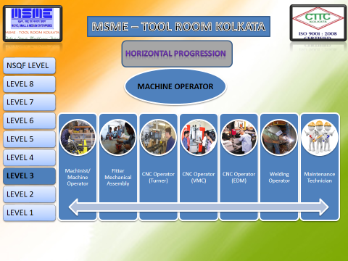
ADVANCE DIPLOMA IN VLSI AND EMBEDDED SYSTEM
Circuit designer
&
Controller programmer
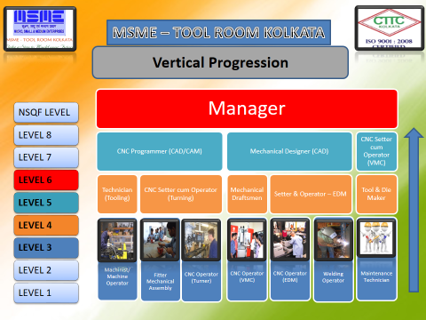
ENGINEER
MP

&

MC

DESIGNER
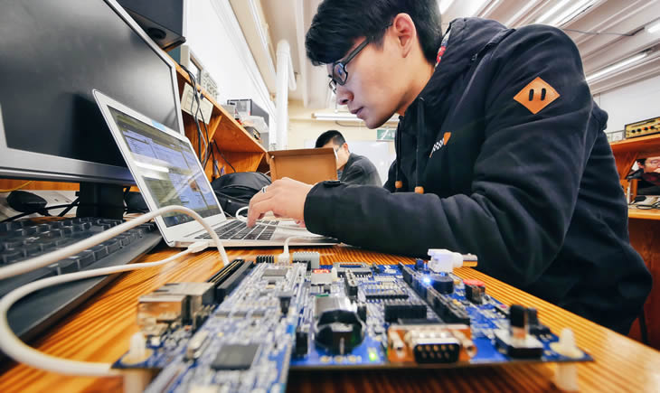
ELECTRONICS CKT DESIGNER
EMBEDDED PROGRAMMER
Level-3
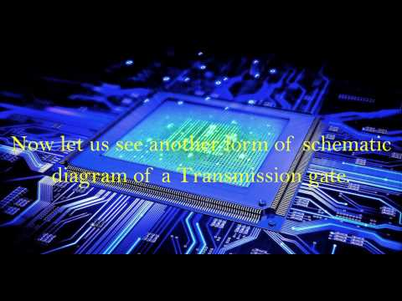
LEVEL-4

COURSE CURRICULUM

Course Title : Advance Diploma in VLSI and Embedded System
Duration : 900 Hrs.

Detailed Syllabus
Week No. | Trade Practical | Trade Theory
1  To  25 | BASIC ELECTRONICS & ELECTRONICS COMPONENTS  1.Measurement and checking of electronic components 2.Circuit designing 3. Soldering and de soldering  COMPUTER FUNDAMENTALS  1.Fault finding and troubleshooting of computer. 2. Ports, slots, external card identification 3.Internal memory, partitioning, and formatting 4.Loading of different kinds of o.s and trouble shooting  NETWORKING  1.Installation of internetworking devices 2.Cable crimping, cable testing,i/o box punching 3.IPVY setup and connectivity 4.Data sharing, remote sharing, remote assistance  DIGITAL ELECTRONICS  1. Logical gates with its truth table and its functionality. 2.Boolean expression minimization K-map solution 3. Combinational Circuits designing using DSCH software  - Adder  - Substractor  - Multiplexer  - Demultiplexer  - Encoder  - Decoder  - Code Converter  - Parity generator and Checker  4.Sequentional Circuits designing using DSCH software  - Flip-Flops  - Counter  - Register  VLSI DESIGN  1.Conversion of chip level design from gate level design 2.Designing of digital circuits(combinational & sequential) using DSCH software 3.Designing of MOSFET using MICROWIND software physical layout design of CMOS & how to make different logical gates using MOS 4.Design of different circuits using MOSFET 5.Basics of VHDL language & how to represent different circuits using this language VHDL programming of circuits in dataflow, behavioral & structural architecture program execution using XILINX software 6.Fundamental of VERILOG-HDL language & how to represent different circuits using this language  7.VERILOG-HDL programming of circuits in dataflow ,behavioral & structural architecture 8.Programming & circuit designing using ALTERA software 9.Downloading of Programming in PLDs(CPLD,FPGA).  EMBEDDED SYSTEM  1. Peripheral interfacing using LGC 2. Understanding of Embedded C programming syntaxes 3.Identification of different peripherals & it’s pin description 4.Interfacing with External Peripherals  - LED(led shifting & flashing)  - LCD(name display in 1 & 2 line)  - 7seg  - D.C. motor (forward & reverse)  - Hex Keyboard  - Relay  5.Interfacing with Internal Peripherals  - GPIO  - DAC  - ADC  - RTC  - PWM  - UART  - PLL  - WDT  ROBOTICS AND VIRTUAL INSTRUMENTATION(LABVIEW)  1.Live practice on C++ based Embedded programming.  - LED.  - LCD.  - 7 Segment.  - Hex Keybord.  - Motor.  2.Driving different types of motor based on IR and HALL EFFECT sensor properties. 3.Assemble LGRobo mobile unit and write a line tracing robo.Detection of black and white line using IR sensor.Obstacle detection using ultrasound sensor. 4.Introduction to LABVIEW software and MYRIO hardware. 5.The uses of the software And hardware in the field of Measurement, Testing &Control. 6.Create project on  - Temparature Conversion.  - Signal Processing  - Image Processing  ELECTRICAL HARDWARE  1.Assignment and practical on Toggle-switch and Push-button, Selector and Limit switch 2. Assignment and practical on Relay, Contactor, Timer and Sensor  PLC  1. NO/NC, SPDTand LATCHING assignment practice 2. Memory bit assignment 3. MOVE and Comparator assignment practice 4.Timer assignment practice 5. Counter assignment practice  EMPLOYABILI-TY SKILL  PROJECT WORK  Idea about the project  INDUSTRIAL VISIT  Workshop and Industry visit | BASIC ELECTRONICS & ELECTRONICS COMPONENTS  1.Introduction to basic electronics. 2.Details about semiconductor ,it’s types & it’s working principle 3. Study of rectifiers, it’s types & it’s functions. 4.Description about transistors it’s types ,it’s working . 5.Study of transistor biasing 6.Discussion about the fundamental electronics components 7.Active and passive components. 8.series parallel circuits 9.Use of the electronics components  COMPUTER FUNDAMENTALS  1.Introduction to different computers and identification. 2.Internal and External Devices. 3.Theory about Memory,mother board, storage devices.  NETWORKING  - Brief idea about network, properties, classification, requirement  - Internetwork device, HUB,SWITCH,NIC,ROUTER etc  - Network Topology.  - Transmission media  wire media, wireless media.  - IP addressing  - Windows networking  DIGITAL ELECTRONICS  1.Number Systems-Study of different number systems and its conversions. 2. Basic knowledge of all Logic Gates. 3. Working principle of different digital circuits. 4. Fundamental of MOSFET & it’s working principle  VLSI DESIGN  1.Knowledge of different types of MOS 2.Theory about VLSI fabrication procedure. 3.Learning different syntaxes of program writing 4.Representation of program coding or logic of different digital circuits 5.Learning different syntaxes of program writing 6.Representation of program coding or logic of different digital circuits  EMBEDDED SYSTEM  1.Basics of processor, controller &embedded system different types of microcontroller. 2.Details of 8085 microprocessor. 3. Details of 8051 microcontroller. 4.ARM7 micro controller & it’s total architecture & it’s function 5.Details about LGC. 6.Basics of ‘C’ Language. 7.Programming using Embedded C language execution of program in CROSSWARE software 8.Hardware demonstration of embedded kit(LPC 2148). 9.Details about ARM7 Peripherals.  ROBOTICS AND VIRTUAL INSTRUMENTATION(LABVIEW)  1.Introduction of Robotics  - History  - Working Principle  - Application.  2.C++ Programming  - C++ class and objects  - Debugging embedded object based programme.  3.Demonstration of LG Robo kit. 4.Theory of Robotics actuators.working principle and application of  - DC motor.  - Servo motor.  - Stepper motor.  5.Theory of Sensors.working principle and application of  - IR-analog sensor  - Hall effect sensor  - Light sensor  - Sound sensor  - Ultrasonic sensor.  5.Introduction to Virtual Instrumentation (Labview).  - Description of front panel and its different tools.  - Numeric Control.  - Numeric Indicator.  ELECTRICAL HARDWARE  1. Introduction to the Electrical Hardware Control 2. Awareness of electrical safety 3. Concept of Control & Power circuit and One Line Diagram 4. Function & application of different types of Switches 5. Introduction to concept of Relay , Contactor, Timer, Sensor  PLC  - Introduction to PLC  - PLC hardware  - Software  - Memory bit  - Communication and  interfacing PLC with physical devices  - SR and RS Block  - Move and comparator  - Counter  - Timer  EMPLOYABILI-TY SKILL  1.communication skill development  2.preparing for GD(group discussion)  3.attitudal behavior  4.personality development  Body language behavior  5.develop the leadership ability  6.preparinf for the interview  PROJECT WORK  Project work  INDUSTRIAL VISIT

EVIDENCE OF LEVEL
NSQF LEVEL – 4

Title/Name of qualification/component:ADVANCE DIPLOMA IN VLSI AND EMBEDDED SYSTEM
NSQF Domain | Outcomes of the Qualification/Component | HOW THE JOB ROLE RELATES TO THE NSQF LEVEL DESCRIPTORS | NSQF LEVEL
Process | Individual performs electronics circuit designing,controller programming, designing technology .He / She considers all relevant aspects for doing the task. | Job that requires well developed skill, with clear choice of procedures in familiar context. | 4
Professional  knowledge | Individual must have knowledge on Electrical & Electronics Engineering . | Knowledge of facts, principles, processes and general concepts, in a field of work or study | 4
Professional  skill | Individual requires skill and technical ability on efficiently using of technical softwares. Must have ability to work effectively with others and as per specify reference procedure. | A range of cognitive and practical skills required to accomplish tasks and solve problems by selecting and applying basic methods, tools, materials and information. | 4
Core skill | Individual understands how to :  •Read and interpret information correctly from various job specification documents, manuals etc.  •Communicate with people in respectful form and manner in line with organizational protocol.  •Undertake basic logic gates operations and circuit designing / programming.  - •Clarify task related information with appropriate or technical adviser.. | Desired  technical skill; understanding of social, political; and some skill of collecting and organising information, communication. | 4
Responsibility | - Expected to work of his own task with minimum of supervision. Taking personal responsibility for own actions and for the quality and accuracy of the work. Identify and solve problems in the course of working. | Responsibility for own work and learning and some responsibility for others’ works and learning. | 4

EVIDENCE OF NEED

What evidence is there that the qualification is needed?

What evidence is there that the qualification is needed?
MSME TOOL ROOM – KOLKATA is a Centre of excellence in the field of vocational and craftsmanship training employing Latest State-of-Art Technology. It has 38 years of experience in the field of vocational education and tool manufacturing and design technology with using latest Automation softwares. With valuable feedbacks, midterm evaluation studies, the need for the qualification has been realised.
What steps were taken to ensure that the qualification(s) does/do not duplicate already existing or planned qualifications in the NSQF?
The qualification is originally designed by curriculum committee comprising the training head, industrial expert, academic professional experts.

The work group under the guidance of curriculum development committee already conducted desk search as well as refers the qualification packs for as a supporting document for the mapping of curriculum.

As per the search it is found that, the certificate course is not available for the skill development of the candidates in Animation Sector under the Media and Entertainment Sector Skill Council.

What arrangements are in place to monitor and review the qualification(s)? What data will be used and at what point will the qualification(s) be revised or updated?

The curriculum committee meeting for review will be in the month of Jan 2018 which comprising industrial expert, university professors with subject specialization.

The data used for revision or update will be impact analysis (student and industries) and new subject area opportunities, multiple entry and exits incorporated or RPL strategy implementations.

The curriculum review and updates, in consultation with industries and expert of respective domain, NOS approved by NSDA will also be referred to from time to time.

