State Competition

Skill- WEB DESIGN and DEVELOPMENT Test Project

Skill Explained

Web Design/Development encompasses many different skills and disciplines in the production and maintenance of websites. The skills required of a web developer are diverse, often to the point it is difficult for a developer to excel in all aspects. As a result, a team may cover the Web Design process, with each member of the team having their own strengths, specialties, and role in the development process.
Web Design involves implementing specific solutions that follow the business rules and objectives outlined by the client. Web Designers develop a professional relationship with their clients, interacting with the in order to develop a deep understanding of the requirements, and convert these into a website specification. Strong design and communication skills, coupled with research techniques and a grasp of target audiences, markets and trends, will ensure initial client satisfaction and credibility for the Web Designer.
Having completed the website planning and design, the Web Designer then integrates the website with third party tools and platforms. During the development process Web Designers implement the design, use their programming skills in order to create dynamic functionalities, test, and debug the website using a variety of devices. The current trend is to also integrate the website with social media to take advantage of the online marketing platforms available.
All these skills may apply equally to the re-design or an upgrade of an existing website. A Web Designer has many employment opportunities. This can range from being a self-employed freelancer, or an entrepreneur, to being employed by advertising agencies and web development companies as well as many different other types of organizations. Web Designer positions may be broad in scope or specialize in an area such as graphic design for the Web, user interface design, digital user experience design, front end development, back end development, content management systems developer as well as client and project management. Whichever role a Web Designer chooses to specialize in they will need to have access to ICT facilities, open source libraries, and frameworks.
High performing Web Designers may have broad or specialist web-related skills. They must understand artistic values, have solid user interface design skills, programming skills, and take personal responsibility for being constantly at the forefront of trends and web technology. They must also be responsive to clients and have the ability to work in structured and unstructured teams and groups. These qualities enable the Web Designer to contribute and take advantage of this rapidly developing aspect of modern communications technology.

Competition Modules Overview

- Module focuses on the Website layout and design
- Create graphics for web
- Use graphics for web
- Create design using provided brief and specification
- Use principal and Techniques for web sites layouts
- Use the current development trends
- Identify the target market and create a concept for the design
- Create design using provided brief and specification
- Use principal and Techniques for web sites layouts
- Use the current development trends
- Develop aesthetically pleasing and creative design.

Client Side and web development

- Integration of the JavaScript’s
- Develop animation to assist in context explanations and visual appeal
- Enhance functionality
- Utilisation of colours, typography and compositions.
- Create code that conforms and validates to the W3C standards
- Use of JavaScript/JQuery to enhance web site functionalities
- Use of CSS3 pre/post process
- Tools used are Adobe creative cloud.
- Working for limitation of Internet enabled devices and Screen resolution
- Application should have the cross-browser compatibility
- Website should assist with search engine performance

Server-Side Module

- Manipulate data using PHP programming skills
- Utilize open source Library and framework
- Use Data modelling techniques to design and implement database with MySQL
- Use of Web Services
- Use the approach of control structured (OOPs)
- Create Secure Application
- Manage data exchange between server and client systems

Eligibility Criteria: Competitors born on or after 01 Jan 1997 are only eligible to attend the Competition

Duration of Test project: 4 hours

Preface

- Section A- Test Project
- Section B- Marking Scheme
- Section C- Infrastructure List (Tool and equipment including raw material)
- Section D- Instruction for Competitors
- Section E- Health, Safety and Environment

Section A – Test Project

Introduction

The Test Project you will be doing is modular and is comprised of 2 modules. Each new module focusing on distinct aspects of the Web Design and Development skill. The modules could be independent or interrelated to the other modules.

General Instructions to the competitor
You will be competing for 2 new modules presented to you in a day. A portion of the module will be completed in the morning (before lunch) and another portion of same will be completed in the afternoon (post lunch). Once the time limit (specified for each module) is completed, your module will be marked.
When you have finished the current module, you can proceed to the requirements for the next module.
Save the final website into your marking folder labeled:
Module Name | Module to be Saved | Duration
Client Site Development | day1_mod_a_xx | 4 hrs.
Server Site Development | Day2_mod_b_xx | 5 hrs.

Where ‘xx’ is FirstName+LastName.
Within each daily folder, save all your created, edited or used source files such as psd/ai files, fla files…etc. in a folder called “source_files_xx”, where ‘xx’ is your unique code.

Day 1 Duration: 4 hrs.
Module “A”: Client Site Development

Introduction

A Dice Car game for kids. Player roll out dice and computer move car on board, square by square. Board has 18 steps. 18th square is the finish square.

Game rules

Car Selection

- Player/s can select the car of their choice

- Player/s drag and drop car on start point.

Dice Roll out

- Player/s rolls dice, is should animate and display the output. It should be smooth

- Each dice rolls out try count is maintained by system.

Car Animation

- As per dice number output respective player/s car animate and move across numbers of squares from lowest to highest number.

- When car moves from each square, It adds 100 points score.

- When car move 10th squares player gets bonus 300 points respectively. Bonus should be shown with animation effects.

- When it reaches to 18th Square it shows the finish with animation. Shows the points earn and numbers of roll out tire.

- Player can start new game any time.
- You may try to enhance the game for more like to be played for more than one player etc.

Sample game area shown below
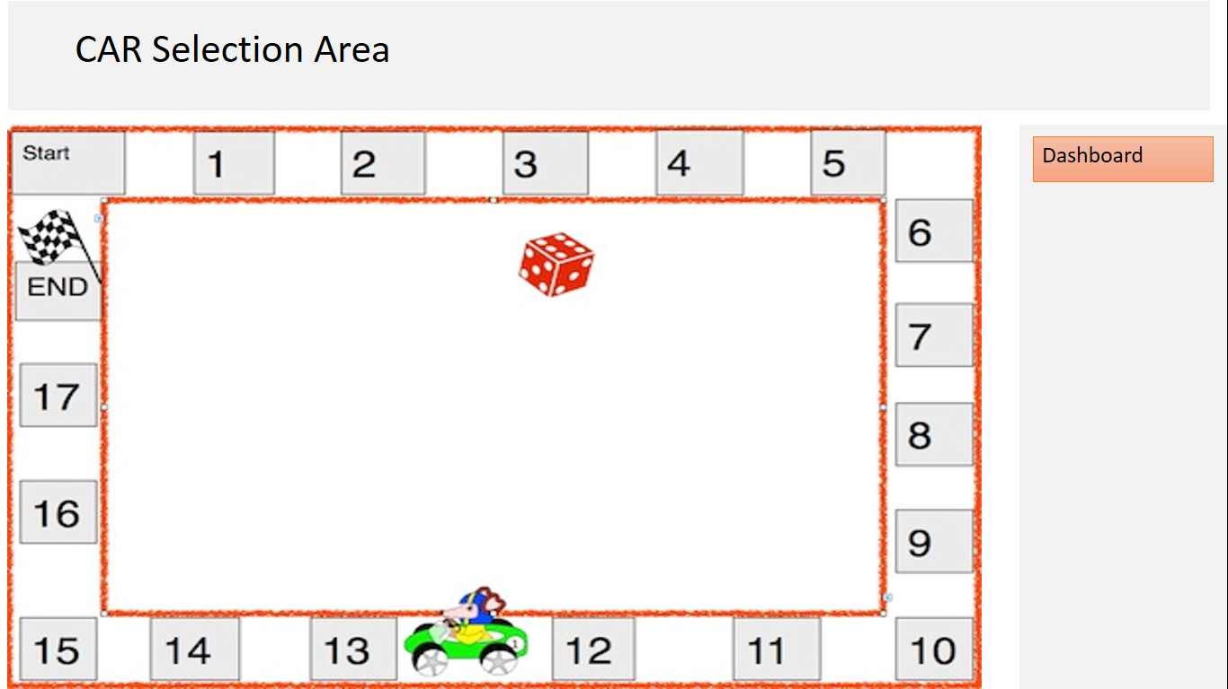

Instructions to the competitor

- Save your file in your C:\ directory on the server called "Day1_Mod_A_XX",
where XX is FirstName+LastName.

Day 1 Duration: 5 hrs.
Module “B”: Server Site Development

Introduction

Your task is to create a reservation booking system for ‘HOT EAT’ Restaurant. You will be marked on your Design, HTML, CSS, PHP, MySQL and Database construction. Marks will also be given for using JavaScript to enhance your application.
The customer call at resultant to book the services. The Manager need the application which will make his task easy.
Description of project and tasks

Display page requirements:

- Display days/dates/tables/visitors in a neat, consistent and organised way.

- Provide an information panel which displays the current number of tables, total number of booked tables and the tables which are currently available driven by PHP (do not use a Javascript solution for this).

- Each booked table will need to display a status of booked and the name, location and phone number of the customer who booked it.

- The information displayed in the information panels for each day is automatically updated when the number of tables and bookings is changed respectively.

Manager requirements:

- Manager can create, update and delete bookings for the tables.

- Only one customer group can be booked at a table at any given time.
- Visitor information is stored in a separate database table to the booking information.

Additional Functionality

- Editor login system.

- Error handling (e.g. when an editor tries to delete a table when someone has booked) (e.g. when an editor attempts to double book a table).

- Accessibility features to enhance the booking system.

- Valid HTML and CSS.

How to build it:

- Design your website thinking about the user experience.

- Cutup up your design using HTML and CSS.

- Program your application using PHP server side programming language
and a MySQL Database.

- Use Javascript that improves your booking system interactivity.

End Result

Save your files in your root server directory and name it Day1_modB_XX (where XX is your competitor FirstName+LastName). Save your native design files in the folder just created and call it Day1_modB_design_XX (where XX is your competitor FirstName+LastName).

.

Section B – Marking Scheme

Marking Scheme:
The Assessment is done by awarding points by adopting two methods, Measurement and Judgments
- Measurement –One which is measurable
- Judgments-Based on Industry expectations
Aspects are criteria’s which are judged for assessment Marking Scheme

Day | Module | Section Criterion | Marks
Day-1 | A | Client Site Development | 50
Day-2 | B | Server Site Development | 50

Module A: Client Site Development
Name of Candidate: ___________________________

Aspect Type 0=Obj/J=Jud | Aspect Description | Max Marks | Obtain Marks
J | The application interface shows the areas requested in the task | 2
J | Shown game area has creative elements | 2
J | Look and feel of the application developed | 2
J | Feedback messages are displays for each steps and appropriate | 2
O | Player can select a car their choice | 2
O | Player can drag a car on start point | 2
O | Player cannot drop more that one car at start square | 1
J | Dice can roll with animations only | 2
J | Look and feel of Dice and animation | 2
O | Car moves nos. of square as per dice output | 4
J | Car movement is animated and smooth | 2
O | 100 points get added on each square car moves | 2
O | Bonus calculated as per specs. | 3
O | Player can restart game | 1
O | Player can exit game | 2
J | Game start with animation | 2
J | Game finishes with animated messages | 2
J | Bonus message is animated | 1
O | System updates Dice count | 2
J | Bonus count is updated with proper effects. | 2
J | JavaScript Coding is working without any errors | 1
O | Java Script is commented | 2
J | All animations does not distract the user | 1
J | Overall functionality as per specs. | 2
J | HTML is commented | 2
J | HTML is valid | 2
TOTAL |  | 50

Module B: Server Site Development

Name of Candidate: ___________________________

Aspect Type | Aspect - Description | Max | Obtain Marks
O = Obj /J = Jud |  | Mark
O | All required elements are present within the interface. | 4
J | Appropriate look and feel for required interface. | 3
J | Quality and originality of elements used within the designs. | 2
J | Consistency of design interface. | 3
O | The HTML and CSS are internally commented to describe code usage. | 2
O | HTML is validated to HTML5 using the W3C validator. | 2
O | CSS is validated to level 3 using the W3C validator. | 2
J | Quality of PHP code used | 2
O | Day/Date/Table/Visitor data is displayed using PHP. | 4
O | Each booked table has its status display updated after it has been booked. | 3
O | The name, location and phone number is available for each booked table. | 2
O | Manager can create, update and delete bookings for tables. | 3
O | Information panel is updated when an Manager makes updates. | 3
O | Only one person can be booked at a table at any one time. | 2
O | An editor login system is working correctly. | 1
O | PHP code has been commented. | 1
J | Error handling has been implemented. | 3
O | Database tables have been created to store module tables, customers and bookings. | 2
J | Correct Data Types have been used. | 2
O | JavaScript has been included to enhance your application. | 1
O | There are no JS errors present within the console. | 1
O | JS Code has been commented. | 1
J | Quality of client side Javascript code used. | 1
TOTAL |  | 50

Section C- Infrastructure List

General Requirements
- Tables with partition for computers
- Tables for Jury
- Chairs for Competitors, Jury, Observers and Workshop team
- Lockers for Competitors
- Printing Paper A4/80g white std.
- Printing Paper A3/ 80g White std.
- Stapler
- Punch machine
- File/Folder
- Standard Set of Cleaning
- Markers
- A4 Bank pages
- Pens for Competitors and Jury
- Pencils & Pencil sharpener
- Eraser

- Ruler
- Post-It
- Plank card for competitor with photo
- Stannard set of Audio Visual
- sellotape
- Standard Set of Health and Safety
- Small cabinmate

System Hardware Requirements
- "Intel® Core™ i5/i7

- Ethernet 10/100/1000 mbps
- 8 GB RAM DDR3 - 1333 MHz
- 2 x LCD Displays 22" LED Wide Screen (02 displays per CPU) (two monitor port)
- Video-card GB GDDR3
- HG 500 GB ,7200 RPM
- Optical mouse with 2 buttons, scroll
- International Keyboard
- USB 2.0(3.0)
- Head Phone

Software Requirements
- Fresh installed Windows 8 and above, with all security patches.

- Google Chrome 64 bit latest

- Firefox 64bit latest

- Internet Explorer – 64 bit

- Sublime text editor 3.0

- Notepad ++7.0/ EditPlus

- PHPStorm

- JQuery

- JQuery-mini

- JQuery-UI

- Adobe Creative Cloud 2017

- XAMPP 7.0

- MS office 2013 and above

- Acrobat reader

- FileZilla Client

- WinZip/WinRAR

Network Requirements
- All system may be connected to switches 100mbps

- Internet speed 1Mbps on internet system.

Backup System Requirements
- All system must be connected to UPS/power backup

- 2 extra system should be available in case of any competitor system fails.

- 2 systems for internet access for the competitor

Other Requirements
- Video Projector with 1920 resolution support

- Projector Screen with stand

- White Board

- Markers

- Stop Watch /Clock

- USB Pen Drives for Expert and Workshop manager

- Printer

Section D- Instruction for Competitors

General Rules

- Competitor should reach venue 15 minute before the entry time.

- Competitor should carry the id proof and birth date proof in original

- No Group work is permitted, it’s individual competition.

- Module briefing will be done before the start of competition

- Module Briefing duration is 15 minutes

- Open communication will be conducted after module briefings

- Open communication duration is 15 minutes

- Module related queries will not be entertain after the start of competition.

Internet Access Rules

- You will have access to internet per module 10 minute except design modules

- Access will be subject to availability of Internet System

- 10 minutes to be utilise at stretch..

- You cannot copy, write from internet machines to your workstation.

- You not permitted to use any communication devices (Chat, Facebook, WhatsApp etc.

Module Rules

- When you have finished the current module, you can proceed to the requirements for the next module.

- Competition Test Project will be in English language

Infrastructure Rules

- Each competitor will get the 30 minutes to test the infrastructure provided before start of competition.

- Any hardware failure during the completion may get extra time subject to approval of Jury/Experts.

- Candidates should not carry any devices, cell phones, material at competition desk.

Rights of competition

- Competitor will be disqualifying for any misbehaviours.

- Jury/Experts decision is final, and no correspondence will be entered.

- All the rights of the competition are revered with skill competition committee.

Section E - Health, Safety, and Environment

- All accredited participants, and supporting volunteers will abide by rules and regulations with regards to Health, Safety, and Environment of the Competition venue.

- All participants, technicians and supporting staff will wear the required protective Personnel clothing.

- All participants will assume liability for all risks of injury and damage to property, loss of property, which might be associated with or result from participation in the event. The organizers will not be liable for any damage, however in case of Injury the competitor will immediately inform the immediate organizer for medical attention.

- For any electrical or technical support contact the expert/supervision staff.

- Do not plugin/plugin out any eclectic & electronics connections, seek for assistance.

- Be careful while working on workstation so that feet should not strike to electric board or CPU system.

