Advance Diploma in Machine Maintenance and Automation

- Course ID : MSME/ADMMA/001
- Candidate Eligibility : ITI in Electronic or Electrical
- No. of NOS (if QP) : Under process
- NSQF Level : 4
- Cost Category : 1
- Course Duration :6 MONTH
- Theory duration: 360HRS.
- Practical: 540HRS.

Trainer Qualification and Work Experience:

Trainer Qualification: Degree or Diploma in Electronic or Electrical and it equivalent

CONTACT DETAILS OF THE BODY SUBMITTING THE QUALIFICATION FILE

Name and address of submitting body:
MSME TOOL ROOM – KOLKATA
(Central Tool Room & Training Centre)
Ministry of MSME, Govt. of India
Bonhooghly Industrial Area
Kolkata – 700108, West Bengal
Ph: (033)25788769,25771068

Name and contact details of individual dealing with the submission
Name: Shri Kanakendu Das

Position in the organisation: Senior Manager-Trig.

Tel number(s): 9231897100

E-mail address: cttc@cal.vsnl.net.in / cttc-msme@gov.in

Qualification Title : | MATER CERTIFICTAE COURSE IN AUTOMATION AND PROCESS CONTROL
Qualification Code | MSME / ADMMA
Nature and purpose of the :  Qualification | Nature of the course is certificate course Passed Degree in Electronics, Electrical or equivalent from any recognized board/institute.  The purpose of the qualification are  •to upgrade the skills and knowledge of people already in work under capital goods sector.  • To give people with professional skill access to the higher education courses.
Body/bodies which will  award the qualification | MSME TOOL ROOM – KOLKATA (Central Tool Room & Training Centre - Kolkata)
Body which will accredit providers to offer courses  leading to the qualification | MSME TOOL ROOM – KOLKATA (Central Tool Room & Training Centre – Kolkata)
Body/bodies which will  carry out assessment of  learners | Examination Cell of MSME TOOL ROOM - KOLKATA
Occupation(s) to which the qualification gives access | Advance Diploma in Machine Maintenance and Automation  ; SECTOR: Automation. SUB SECTOR: Instrumentation & Service Engineer.
Licensing requirements | NA
Level of the qualification in  the NSQF | 4
Anticipated volume of  training/learning required to complete the qualification | Six months; 900 hrs  Sr. No Course Elements Hourly Distribution  1 Professional skill 400 hrs.  2 Professional Knowledge 360 hrs.  3 Employability Skill 90 hrs.  4 Extra – Curricular – Activities 25 hrs.  5 Examination 25 hrs.  Total 900 hrs
Entry requirements and/or  recommendations | Passed Degree in Electronics, Electrical or equivalent from any recognized board/institute. Minimum 18 years of age
Progression from the  qualification | Qualifying trainee should obtain a NSQF certificate in MCCAPC(Master Certificate Course in Automation & Process Control)  This qualification shall enable the trainee to find employment on a Super-skilled work / Design department with Automation field of applications in level 4 of NSQF.
Planned arrangements for the Recognition of Prior  learning (RPL) | The student who has passed Diploma & Degree this qualification will be able to take admission in next higher level of study.
International comparability  where known | Existence of any official document suggesting the comparability of the qualification with the qualifications in other countries is not known.  Survey is suggested.
Date of planned review of the qualification. | After 3 years of recognition. September, 2019

Formal structure of the qualification

Title and identification code of component. | Mandatory/  Optional | Estimated size  (learning hours) | Level
Master Certificate Course in Automation & Process Control  I Code : CSC/N XXXX  •Professional skill  Development of hands-on –skill and knowledge in order to educate a learner to design of different automation logics using Software.  •Professional Knowledge  All relevant theoretical topics on the applications of software- Simatic Manager, PCS7, Wincc | Mandatory  ,, | 400 hrs  360 hrs | 4  4
•Employability Skill  CSC/N 1335 (Basic health and safety practices at the work place  CSC /N 1336 (Work effectively with others,  Communication and IT skill) | ,, | 90 hrs
•Extra – Curricular – Activities  • Examination | ,,  ,, | 25 hrs  25 hrs
Total |  | 900 hrs

ASSESSMENT
Body/Bodies which will carry out assessment:
Examination Cell of MSME Tool Room – Kolkata
Will the assessment body be responsible for RPL assessment?
: Yes. Assessment body will be responsible for RPL assessment.
How will RPL assessment be managed and who will carry it out?
The Learners who have met the requirements of any Unit Standard that forms part of this qualification may apply for recognition of prior learning (RPL) to the relevant Education body/Institute with proper evidences. The applicant must be assessed against the specific outcomes and with the assessment criteria for the relevant Unit Standards by the Assessment Body of Respective Institute.
Describe the overall assessment strategy and specific arrangements which have been put in place to ensure that assessment is always valid, reliable and fair and show that these are in line with the requirements of the NSQF.
The assessment for the Session -based qualification is carried out by conducting formative assessments, and end-of-session examinations for all trainees aspiring for this qualification, as per the guidelines given. The internal assessments for theory subjects and practical are conducted by the concerned instructors for evaluating the knowledge and skill acquired by trainees and the behavioural transformation of the trainees as per the learning outcomes specified the qualification. This assessment is primarily carried out by collecting evidence of competence gained by the trainees by observing them at work, asking questions and initiating formative discussions to assess understanding and by evaluating records and reports, and marks are awarded to them. Theory examinations are conducted in Machine Shop Theory, Engineering Metrology, Workshop Calculation & Science, Engineering Drawing and Employability Skills. The question papers for the theory Examinations contain objective type questions. Trade practical examinations are conducted. Criteria for assessment based on each learning outcomes, will be assigned marks proportional to its importance. The assessment for the theory &practical part is based on knowledge bank of questions created by trainers and approved by Examination cell/Assessment body. The distribution of marks for the qualification is as under:
ELIGIBILITY TO APPEAR IN THE EXAM: Minimum 75% class attendance is compulsory for the students to appear for the assessments

Sr. No. | Method of Assessments | Weight age (Max. marks) | Evaluator
1 | Written test | 30 | Trainer+ Examiner nominated by Examination cell (CTTC,KOLKATA)
2 | Practical test | 30
3 | Oral test/viva voce | 10
4 | Portfolio | 10
5 | Project | 10
6 | Direct Observation | 10
Total |  | 100

Minimum pass mark (COMPETENT): 40% for each theory subject and 60% for practical;
Fail candidates are entitled three chances to clear the paper.

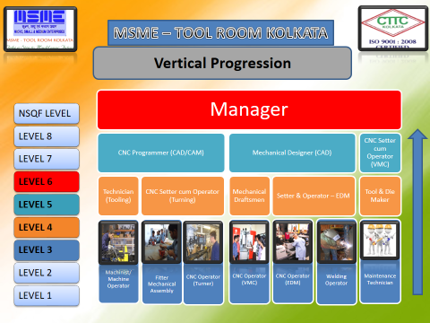
supervisor
AUTOMATION PROGRAMMER
AND MAINTENANCE
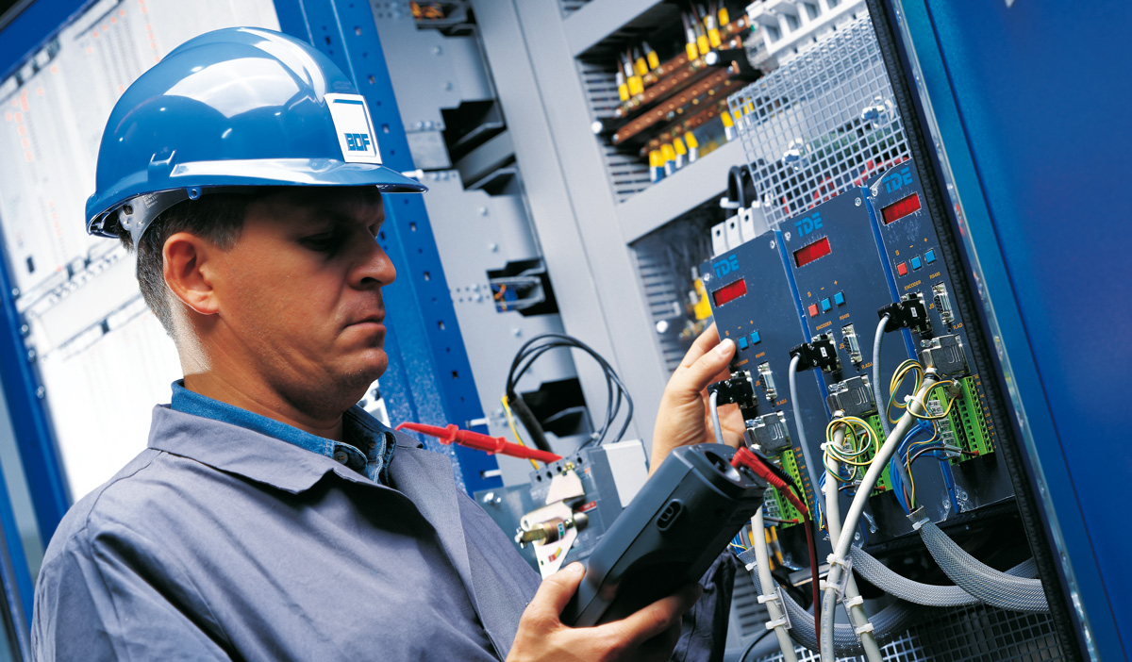

RESULTS AND CERTIFICATION: Successful trainees will be awarded the Final Mark Sheet and Certificates by MSME TECHNOLOGY CENTRE.

ASSESSMENT EVIDENCE: Assessment evidence comprises the following components document in the form of records:
- Job carried out in labs/workshop ; Record book/ work diary
- Examination - Answer sheet of assessment
- Viva –voce ; Class test
- Progress chart ; Attendance and punctuality
- Assignment of practical exercise job ; Practical Exam for each module

Title of Component: Advance Diploma in Machine Maintenance and Automation

Assessable outcomes:

Assessable Outcomes | Assessment Criteria
Use basic health and safety practices at the  Workplace, environment regulation and housekeeping  ` | Use protective clothing/equipment for specific tasks and work conditions
 | State the name and location of people responsible for health and safety in the workplace
 | State the names and location of documents that refer to health and safety in the workplace
 | Identify job-site hazardous work and state possible causes of risk or accident in the workplace
 | Carry out safe working practices while dealing with hazards to ensure the safety of self and others state methods of accident prevention in the work environment of the job role
 | State location of general health and safety equipment in the workplace
 | Inspect for faults, set up and safely use steps and ladders in general use
 | Work safely in and around trenches, elevated places and confined areas
 | Lift heavy objects safely using correct procedures
 | Apply good housekeeping practices at all times
 | Identify common hazard signs displayed in various areas
 | Retrieve and/or point out documents that refer to health and safety in the workplace
 | Use the various appropriate fire extinguishers on different types of fires correctly
 | Demonstrate rescue techniques applied during fire hazard
 | Demonstrate good housekeeping in order to prevent fire hazards
 | Demonstrate the correct use of a fire extinguisher
 | Demonstrate how to free a person from electrocution
 | Administer appropriate first aid to victims where required eg. in case of bleeding, burns, choking, electric shock, poisoning etc.
 | Demonstrate basic techniques of bandaging
Respond promptly and appropriately to an accident situation or
medical emergency in real or simulated environments
Perform and organize loss minimization or rescue activity during an
accident in real or simulated environments
 | Administer first aid to victims in case of a heart attack or cardiac arrest due to electric shock, before the arrival of emergency services in real or simulated cases
 | Demonstrate the artificial respiration and the CPR Process
 | Participate in emergency procedures
 | Complete a written accident/incident report or dictate a report to another person, and send report to person responsible
 | Demonstrate correct method to move injured people and others during an emergency
Work effectively  with others, work in a team, understand and practice soft skill technical English to communicate with required clarity.  Understand and apply basic computer working and uses internet services to get accustomed and take benefit of IT development in the industries | Accurately receive information and instructions from the supervisor and fellow workers, getting clarification where required
 | Accurately pass on information to authorized persons who require it and within agreed timescale and confirm its receipt
 | Give information to others clearly, at a pace and in a manner that helps them to understand
 | Display helpful behaviour by assisting others in performing tasks in a positive manner, where required and possible
 | Consult with and assist others to maximize effectiveness and efficiency in carrying out tasks
 | Display appropriate communication etiquette while working
 | Display active listening skills while interacting with others at work
 | Use appropriate tone, pitch and language to convey politeness, assertiveness, care and professionalism
 | Demonstrate responsible and disciplined behaviours at the workplace
 | Escalate grievances and problems to appropriate authority as per procedure to resolve them and avoid conflict
 | Their applications will be assist during execution of accessible outcome

EVIDENCE OF PROGRESSION
What steps have been taken in the design of this or other qualifications to ensure that there is a clear path to other qualifications in this sector?
Qualified learner of this qualification will obtain NSQF compliance certificate in the trade of industrial automation which place the learners in the position to level 4 of NSQF.
There is a clear path for progression to higher level of qualification.
There is a facility of mobility for vertical progression from qualification to qualification (same level as well as higher level) within the sector/sub sectors.

Course curriculum:

Sr. No. | Outcomes to be assessed | Assessment criteria for the outcome
 | Electrical Hardware Control | The candidate should get the knowledge of  1.1. Introduction to the Electrical Hardware Control  1.2. Awareness of electrical safety  1.3. Concept of Control & Power circuit and One Line Diagram  1.4. introduction to the different types of Switches  1.5. Function & Applications of Toggle-switch and Push-button  1.6. Selector and limit switch  1.7. Introduction to concept of Relay  1.8. Introduction to concept of Contactor  1.9. Introduction to concept of Timer  1.10. Introduction to concept of Sensor
2 | PLC & Its programming Software. | 2.1 Introduction to PLC  - PLC hardware  - Software  - Memory bit  - Communication and  interfacing PLC with physical devices  - SR and RS Block  2.7 Move and comparator  - Counter  - Timer  - Flasher  - FB,FC,DB  - Analog scaling  - FBD  - STL  - Networking
3 | SCADA | - Introduction to SCADA  - Application and features of SCADA  - Introduction to the software of SCADA  - Steps to open the software and how to create the project  - How to interface SCADA with PLC ,How to create graphics using software Analog tag management
4 | HARDWARE & NETWORKING | 4.1. Discussion about the fundamental electronics components  4.2. Active and passive components  4.3. Series parallel circuits  4.4. Use of the electronics components  4.5. Number system  4.6. Analog and digital computers, mother board, memory, managerial storage device operating system  4.7. Un regulated and regulated power supply  4.8. Block diagram description of switch mode power supply  4.9. Brief idea about network, properties, classification, requirement  4.10. Internetwork device, HUB,SWITCH,NIC,ROUTER etc  4.11. Transmission media wire media, wireless media.  4.12. Ip addressing  4.13. Windows networking
5 | HYDRAULICS & PNUEMATICS | 5.1 Basic principles of pneumatic system ( Properties of air, basic pneumatic system , applications, advantage and disadvantage )  - Pneumatic compressor and energy supply element (piston type,vane type, screw type)  - Pneumatic air treatment (receiver, air filter, pressure regulator,lubricator)  - Directional control valve(check valve, flow control valve, shuttle valve, two pressure valve, time delay valve)  - Basic principles of electrical circuit on pneumatic system  - Basic principles of relays, sensor, solenoid coil  - Interfacing electro-pneumatic system with PLC and SCADA (basic operation of PLC device )  - Basic principles of hydraulic system (PASCALS law, close loopsystem , open loop system, application, advantage , disadvantage )  - Hydraulic Pumps ,Valves , Actuators , Accumulator (gear pump,  vane pump, piston pump, pressure control valve, direction control valve, flow control valve, hydraulic motor, hydraulic cylinder , (double acting and single acting ),weight loaded type, spring loaded type, gas loaded type  5.10 Hydraulic fluid( hydraulic fluid property , various hydraulic fluid ,laminar flow, turbulent flow, Reynolds number )
6 | AUTOCAD | 6.1 Introduction to the co-ordinate system.  - Introduction to the different types of commands  - Uses of different types of commands  - How to draw the line, circle, arc, polygon, array, ellipse, chamfer, fillet.  - Command uses for AUTOCAD-software  - Uses of commands to design the different electrical circuit
7 | MACHINE MAINTENANCE | 7.1. Practise and exercise on CNC milling and turning  7.2. CNC lathe maintenance
8 | DCS & DRIVES | - Introduction to the DCS  - Application of the DCS system in the field of industrial automation  - Introduction to the AC drives  8.4 Application drives system
Means of assessment 1 and 2
Skill performance is assess by conducting
- Assignment for each module
- Written test for each module
- Final exam after completion of all module
- Practical exam for each module
- Final practical exam after completion of all module
- Viva / Oral Exam
- Project report and presentation
Pass/Fail
Passing criteria is based on marks obtain in attendance record, term works , assignments, practical’s performance, viva or oral exam, module test, practical exam and final exam
- Minimum Marks to pass practical exam – 70%
- Minimum Marks to pass final exam – 70%
- Minimum Marks to pass viva / oral exam –70%
- Minimum Marks to pass Project report and presentation exam – 90%

Pass/Fail : 40% for each theory ; 50% for practical
Fail candidates are entitled three chances to clear the paper.

EVIDENCE OF LEVEL

NSQF LEVEL – 4

Title/Name of qualification/component: ADMMA
Level: 4
NSQF Domain | Outcomes of the Qualification/Component | How the job role relates to the NSQF level descriptors | NSQF Level
Process | Individual performs LAD designing technology .He / She considers all relevant aspects for doing the task. | Job that requires well developed skill, with clear choice of procedures in familiar context. | 4
Professional knowledge | Individual must have knowledge on Electrical & Electronics Engineering. | Knowledge of facts, principles, processes and general concepts, in a field of work or study. | 4
Professional skill | Individual requires skill and technical ability on efficiently using of technical software’s. Must have ability to work effectively with others and as per specify reference procedure. | A range of cognitive and practical skills required to accomplish tasks and solve problems by selecting and applying basic methods, tools, materials and information. | 4
Core skill | Individual understands how to :  •Read and interpret information correctly from various job specification documents, manuals etc.  •Communicate with people in respectful form and manner in line with organizational protocol.  •Undertake basic numerical operations and calculations / formula.  •Indentify various basic, compound and solid shape as per dimensions given.  •Use appropriate measuring techniques and units of measurements and also units and numbers systems to express degree of accuracy.  •Clarify task related information with appropriate or technical adviser. | Desired  technical skill; understanding of social, political; and some skill of collecting and organising information, communication.
Responsibility | Expected to work of his own task with minimum of supervision. Taking personal responsibility for own actions and for the quality and accuracy of the work. Identify and solve problems in the course of working. | Responsibility for own work and learning and some responsibility for others’ works and learning. | 4

EVIDENCE OF NEED

What evidence is there that the qualification is needed?
MSME TOOL ROOM – KOLKATA is a Centre of excellence in the field of vocational and craftsmanship training employing Latest State-of-Art Technology. It has 38 years of experience in the field of vocational education and tool manufacturing and design technology with using latest Automation software’s. With valuable feedbacks, midterm evaluation studies, the need for the qualification has been realised.
What is the estimated uptake of this qualification and what is the basis of this estimate?
100 learners per year.
What steps were taken to ensure that the qualification(s) does (d0) not duplicate already existing or planned qualifications in the NSQF?
The qualification is newly designed on the basis of NSQF norms and guidelines.
What arrangements are in place to monitor and review the qualification(s)? What data will be used and at what point will the qualification(s) be revised or updated
A mentor body / committee has to be formed to review curriculum of this qualification under this sector.

EVIDENCE OF PROGRESSION

What steps have been taken in the design of this or other qualifications to ensure that there is a clear path to other qualifications in this sector?
Successful qualified trainee will obtain NSQF compliance certificate in the trade of “ADVANCE DIPLOMA IN MACHINE MAINTENANCE AND AUTOMATION”, which place the trainees in position to a level 4 of NSQF descriptors. There is a path for progression to other / higher level of qualification in this sector.

