**State Level Skill Competitions**

**Skill-Mechanical Engineering Design Test project- Level 2**

**Skill Explained**

Computer aided design is the use of computer systems to assist in the creation, modification, analysis, or optimization of an engineering design. CAD software is used to increase the productivity of the designer, improve the quality of design, improve communication through documentation, and create a database for manufacturing. CAD output is often in the form of electronic files for print, manufacturing or other manufacturing processes. The technical and engineering drawings and images must convey information such as materials, processes, dimensions and tolerances according to application-specific conventions.

**Eligibility Criteria**- Competitors born on or after 01 Jan 1997 are only eligible to attend the Competition

**Duration of Test project: 4 hours**

**Preface**

**Section A**-Test Project

**Section B**-Marking Scheme

**Section C**-Infrastructure List (Tool and equipment including raw material)

**Section D-** Instruction for Competitors

**Section E**- Health, Safety and Environment

**Section A**

**Prerequisites for the State/District Competition:**

* Familiarity with the software. (Autodesk Inventor - v.2016 and above)
* To interpret 2D drawings & create 3D models from detail drawings;
* To create an assembly of parts in 3D & to produce detail drawing(s)
* Selection of standards from content library
* Familiarity with Basic measuring instruments like Vernier caliper, Micrometer & radius gauges and Angle measuring instruments

Knowledge in Geometrical dimension and tolerances.

**Details of the competition:**

* The competitor must be able to read the drawing, model the 3D model, create the 2D drawings from the CAD Model created and dimension it as per the specifications mentioned in the drawing with necessary tolerances and manufacturing symbols. The completed test projects will be evaluated by a jury panel. The test duration is for 4 Hrs. The competition will be on Autodesk Inventor version v.2016 and above.
* The test is for 50 marks
* The below drawing is an example of
* **First test – Mechanical Assemblies and detail drawings for manufacture.**







**Figure 1- Mechanical Assemblies & detail drawings for manufacture**

**Second level**

Test will be for 75 marks and for a duration of 4 + 2 Hrs. It will be featuring an additional test of measuring and modelling from a physical part which is called reverse engineering by use of simple measuring tools like Vernier calliper, Micrometer, Radius and Thread Pitch gauges.

* The below parts are examples of **Second test – Reverse Engineering from a Physical part**

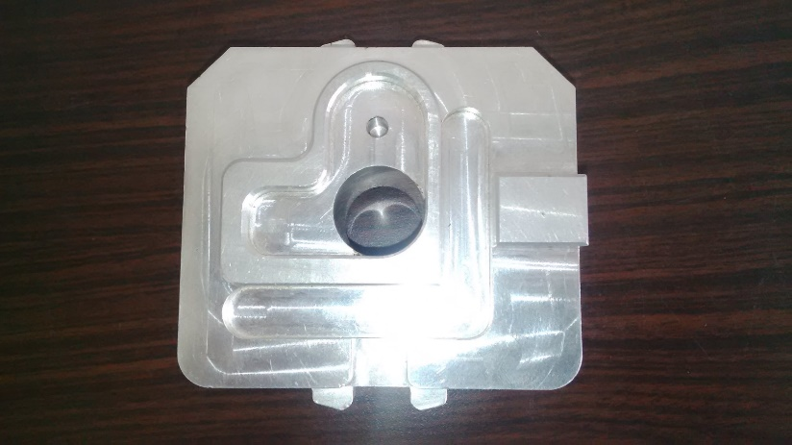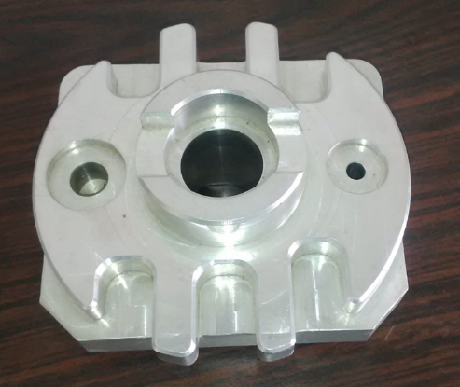

**Section B**

**Marking Scheme:** The Assessment is done by awarding points by adopting two methods, Measurement and Judgments

* Measurement –One which is measurable
* Judgments--Based on Industry expectations
* Aspects are criteria’s which are judged for assessment

**Scheme of marking:**

**First test: Mechanical Assemblies and detail drawings for manufacture**

Create part models for all parts mentioned in the drawing - **20 Marks** (All measurable)

Create detailed 2D drawing and Assembly drawings– **20 marks**

* + (Judgemental: 4-5%, Measurable 90-96%) Approx.

Dimensioning and Part list (BOM) – **10 marks**

* + (Judgemental: 4-5%, Measurable 90-96%) Approx.

|  |  |  |  |
| --- | --- | --- | --- |
| **Criteria** | **Judgment** | **Measurement** | **Total** |
| Part modeling |  | 20 | 20 |
| Assembly modeling |  | 30 | 30 |
| Dimensioning (Inc. GDT) |  | 30 | 30 |
| Drawing views and presentation | 4 | 16 | 20 |
| Grand Total | 4 | 96 | 100 |

Further breakup into detailed marking scheme:

**Judgment Marking Form**

Skill Number: __05___ Skill Name: Mechanical Engineering Design-CAD

Competitor No: Competitor Name:

Sub criterion: Drawing views and presentation

|  |  |  |  |  |  |  |  |  |
| --- | --- | --- | --- | --- | --- | --- | --- | --- |
| Aspect  ID | Max  Mark | Aspect Criterion – Description |  | Experts Score (0 – 3) | | |  | Mark  Awarded |
| 1 | 2 | 3 |
|  | 2.0 | Rendered image |  |  |  |  |  |  |
|  | 2.0 | Animation |  |  |  |  |  |  |

4.00 Maximum Mark for Sub criterion Mark Awarded 0.00

Signatures of experts selected to confirm the accuracy of this printed result

∑ Scores x (Max Mark)

Mark Awarded = -----------------------------

Chief Expert

Compatriot Expert 1

Date and Time

**Measurement Marking Form**

Skill Number: 05 Skill Name: Mechanical Engineering Design-CAD

Competitor No: Competitor Name:

Sub criterion: Part modeling

|  |  |  |  |  |  |  |  |
| --- | --- | --- | --- | --- | --- | --- | --- |
| Aspect  ID | Max  Mark | Aspect Criterion – Description |  | Requirement or Nominal Size | Result or Actual Value |  | Mark  Awarded |
| A | 2 | Body |  | Presence of the part |  |  |  |
| B | 2 | Barrel |  | Presence of the part |  |  |  |
| C | 2 | Spindle with washer & nut |  | Presence of the part |  |  |  |
| D | 2 | Centre |  | Presence of the part |  |  |  |
| E | 2 | Spindle bearing |  | Presence of the part |  |  |  |
| F | 2 | Hand Wheel |  | Presence of the part |  |  |  |
| G | 2 | Clamping lever |  | Presence of the part |  |  |  |
| H | 2 | Feather Key |  | Presence of the part |  |  |  |
| I | 2 | Screw |  | Presence of the part |  |  |  |
| J | 2 | Full Assembly |  | Presence of the part |  |  |  |

20.00 Maximum Mark for Sub criterion Mark Awarded 0.00

Signatures confirming the accuracy of this entry result

Date and Time

Chief Expert

Expert 1

Measurement Marking Form

Skill Number:__05 _ Skill Name : Mechanical Engineering Design-CAD

Competitor No: _______ Competitor Name:

Sub criterion: Assembly modeling

|  |  |  |  |  |  |  |  |
| --- | --- | --- | --- | --- | --- | --- | --- |
| Aspect  ID | Max  Mark | Aspect Criterion – Description |  | Requirement or Nominal Size | Result or Actual Value |  | Mark  Awarded |
| a | 3 | Spindle Sub-Assembly |  |  |  |  |  |
| b | 3 | Main assembly |  |  |  |  |  |
| c | 3 | Assembly without sub-assembly |  |  |  |  |  |
| d | 3 | Exploded view of main assembly |  |  |  |  |  |
| e | 3 | Exploded view Spindle Assembly |  |  |  |  |  |
| f | 3 | Item list |  |  |  |  |  |
| g | 3 | Part number details |  |  |  |  |  |
| h | 3 | Title block |  |  |  |  |  |
| i | 3 | Dimensioning |  |  |  |  |  |
| j | 3 | Volume |  |  |  |  |  |

30.00 Maximum Mark for Sub criterion Mark Awarded

Signatures confirming the accuracy of this entry result

Date and Time

Chief Expert

Expert 1

Measurement Marking Form

Skill Number:__05 _ Skill Name : Mechanical Engineering Design-CAD

Competitor No: _______ Competitor Name:

Sub criterion: Dimensioning (Incl. GD&T)

|  |  |  |  |  |  |  |  |
| --- | --- | --- | --- | --- | --- | --- | --- |
| Aspect  ID | Max  Mark | Aspect Criterion – Description |  | Requirement or Nominal Size | Result or Actual Value |  | Mark  Awarded |
| a | 3 | Body |  | Dimensions |  |  |  |
| b | 3 | Barrel |  | Dimension |  |  |  |
| c | 3 | Spindle with washer & nut |  | Dimension |  |  |  |
| d | 3 | Centre |  | Dimension |  |  |  |
| e | 3 | Spindle bearing |  | Dimension |  |  |  |
| f | 3 | Hand Wheel |  | Dimension |  |  |  |
| g | 3 | Clamping lever |  | Dimension |  |  |  |
| h | 3 | Feather Key |  | Dimension |  |  |  |
| i | 3 | Screw |  | Dimension |  |  |  |
| j | 3 | Full Assembly |  | Dimension |  |  |  |

30.00 Maximum Mark for Sub criterion Mark Awarded

Signatures confirming the accuracy of this entry result

Date and Time

Chief Expert

Expert 1

Measurement Marking Form

Skill Number: __05 _ Skill Name: Mechanical Engineering Design-CAD

Competitor No: _______ Competitor Name:

Sub criterion: Drawing views & Presentation

|  |  |  |  |  |  |  |  |
| --- | --- | --- | --- | --- | --- | --- | --- |
| Aspect  ID | Max  Mark | Aspect Criterion – Description |  | Requirement or Nominal Size | Result or Actual Value |  | Mark  Awarded |
| a | 4 | All drawings |  |  |  |  |  |
| b | 3 | All 2D detail drawings |  |  |  |  |  |
| c | 3 | Rendered image in Defined format |  |  |  |  |  |
| d | 3 | Animation Duration. |  |  |  |  |  |
| e | 3 | All 3d assembly drawings |  |  |  |  |  |

16.00 Maximum Mark for Sub criterion Mark Awarded

Signatures confirming the accuracy of this entry result

Date and Time

Chief Expert

Expert 1

**MARKING SUMMARY FORM**

Skill No: 05 Skill Name: Mechanical Engineering Design-CAD

Competitor No: ______ Competitor Name: ________________

|  |  |  |  |
| --- | --- | --- | --- |
| Criterion  ID | Criterion Description | Max | Actual |
| B1 | Part modeling | 20 |  |
| B2 | Assembly modeling | 30 |  |
| B3 | Dimensioning (Inc. GDT) | 30 |  |
| B4 | Drawing views and presentation | 20 |  |
| Grand total | | 100 |  |

|  |  |
| --- | --- |
| Result confirmed by | Signed with date |
| Compatriot/Independent expert |  |
| Chief expert |  |
| Jury president |  |

**Second test: Reverse Engineering from a physical model**

Presence of all features- 10 marks

Create detailed 2D drawing – 10 marks (All Measurable)

* (Judgemental: 4-5%, Measurable 90-96%) Approx.

Dimensioning – 05 marks

* (Judgemental: 4-5%, Measurable 90-96%) Approx.

|  |  |  |  |
| --- | --- | --- | --- |
| **CRITERION** | **Judgment** | **Measurement** | **MARKS** |
| Presence of part features |  | 44 | 44 |
| Dimensions |  | 30 | 30 |
| Tolerances (Including GD&T) |  | 12 | 12 |
| Surfaces |  | 8 | 8 |
| Presentation | 6 |  | 6 |
| **Total**: | 6 | 94 | 100 |

The marking scheme for this module “Reverse Engineering” is quite similar to the one shown (above) in the module “Mechanical assemblies and detail drawings for manufacture”

**Section C**

**Infrastructure and facilities**

* Institute/ Engineering colleges with Computer labs having Workstations with a minimum configuration of
  + 8 GB RAM
  + Disk Space: 40 GB
  + Microsoft Direct3D 10® capable graphics card or higher
* Authorized Autodesk Training centers.
* Tool list

|  |
| --- |
| Vernier/Dial/ Digital Caliper |
| Vernier/Dial Digital Offset Centerline Caliper |
| Digital or Universal Protractor |
| Radius Gages (0.4 to 25mm) |
| External Metric Thread Pitch Gage (0.35 to 6mm) |
| Internal Metric Thread Pitch Gage (0.35 to 6mm) |
| Surface comparator gauges (Ra) (not mandatory) |
| Metallic Ruler (0-300mm) |
| Vernier/Dial/ Digital Depth Gage Caliper (0-150mm or 0-200mm) |

**Section D**

**Instructions for Competitors**

* Read the competitor instructions carefully. (Print given to you along with the drawings)
* Study the drawing and interpret all the details given to you.
* Take a proper attention towards all the deliverables asked for.
* Your exam will be stopped exactly after the time allotted.
* Don’t attempt to talk to any other competitor.
* Always ask the exam coordinator for any clarification needed.
* Handover all the deliverables to the exam coordinator at the end of the test.

**Section E**

1. All accredited participants, and supporting volunteers will abide by rules and regulations with regards to Health, Safety, and Environment of the Competition venue.
2. All participants, technicians and supporting staff will wear the required protective Personnel clothing.
3. All participants will assume liability for all risks of injury and damage to property, loss of property, which might be associated with or result from participation in the event. The organizers will not be liable for any damage, however in case of Injury the competitor will immediately inform the immediate organizer for medical attention.