



**Test Project**

**State Level Skill Competitions**

**Skill-Mobile Robotics**

Category: Manufacturing & Engineering Technology

**Table of Contents**

**A. Preface 3**

**B. Test Project 4**

**C. Marking Scheme 7**

**D. Infrastructure List 9**

**E. Instructions for candidates 10**

**F. Health, Safety, and Environment 11**

**Section - A**

# **A. Preface**

**Skill Explained:**

Robotics is the branch of technology that deals with the design, construction, operation, structural disposition and application of robots. Mobile Robotics is a fast evolving, solutions orientated. Industrial mobile robotics is an important part of the industry, with applications in diverse industries, including manufacturing, agriculture, aerospace, mining, and medicine. Presently there is a need to create robots to increase the capacity for tasks that can be automated. The competitors are expected to develop a test project to solve a real time industrial application with a total automated solution.

**Eligibility Criteria (for IndiaSkills 2018 and WorldSkills 2019):**

Competitors born on or after 01 Jan 1997 are eligible to attend the Competition. The team consists of 2 competitors.

**Total Duration: 8 Hours**

**Section - B**

# **B. Test Project**

**Prerequisites:**

Competitors are required to design and fabricate a robot on the guidelines of the declared test project. The Sample Test Project is subjected to minimum 30% change. However, changes shall not require any change in the infrastructure requirements. The competitors shall be required to submit a soft copy of the technical documentation of the fabricated robot. The documentation shall include the Frame / Structural Elements Organization, the Wiring System Organization, the Mobility Management System Organization, the Object Management System Organization, the Computer Programming Organization.

Robot structure shall be fabricated by the competitors prior to the competition; no readymade structural components shall be used by the competitors. However, Robot shall be dismantled and reassembled at the competition venue.

**Theme (Playground Monitor Robot):**

The children are playing in the playground. The parents are waiting outside the game field. The area where the parents are waiting is called **Archway**. Each of the **parents has one children each.** The **task of the robot is to deliver the child to the corresponding parent**. A set of **plastic solid colour balls** of diameter 2.25 inches (Red, Green, Blue, Yellow, Violet), will fill the role of ‘Children’ in the Playground Monitor Robot Task and **grid patterns** shall play the role of parents. The Competitor built Robots task is to travel from the Playground, pick up the Designated ‘Child of Interest’ and deliver each of the Child to the Correct Parent.

The competitors also have to design the mobile robot in such a way that it is capable of performing the task in tele-operation / semi-autonomous mode. The Teams shall get maximum 10 minutes to pick up 3 children. The Object Management System and the Robot in combination can be in possession of a **Maximum of ONE Child** at a time.

* The competitors are preferably suggested use **National Instruments Myrio-1900 controller and LabVIEW software,** however are competitors are free to any other alternative.
* The robot should be equipped with a **camera** to transmit the video signal **wirelessly**.

Example of parent grid and designated child ( i.e balls):





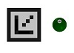

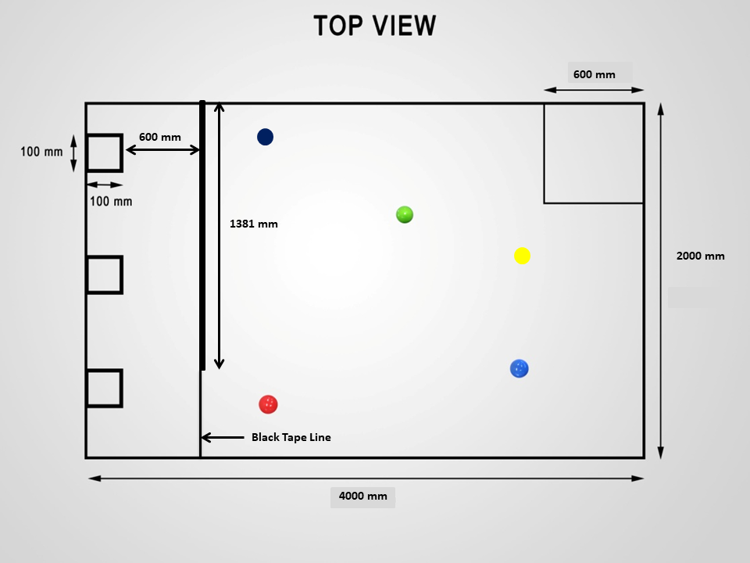

**A**

**R**

**C**

**H**

**W**

**A**

**Y**

### *The Playground’s top view*

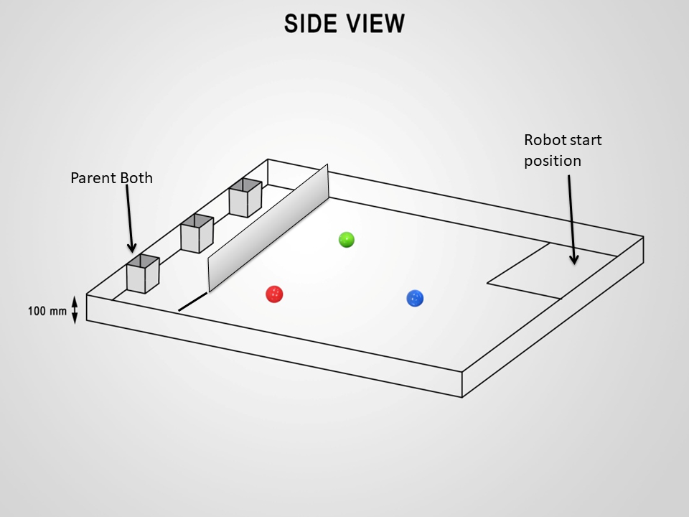

*The Playground’s isometric view*

* The game field shall be a court of area 4m X 2m.
* A Row of three hollow Parent Booth of size 100 mm X 100mm with 100mm height.
* The Archway wall shall be 1381 mm X 200mm X 6mm transparent plastic sheet.
* The Parent Grid Patterns will be pasted on the parent booth.
* The Designated Robot Starting Position is Inside a 600 by 600 mm Tape Line Square.
* The Competitor Built Robots Task is to travel from the Playground pickup one ball at a time, and delivered (to be placed inside the hollow booth area) to each of the Correct Parent.

**Module 1:- Tele-operation Mode – No direct line of sight**

* The expert will fix 5 random positions for children in the playground. These positions will remain same for all the teams (Three children shall be delivered to the parents as randomly decided by the experts before the start of the game)
* The sequence of the position will be decided on the roll of dice for each team before the performance test run.
* The robot should be placed at start position.
* During the performance test, the competitor shall sit at workstation near the arena facing their back towards the arena.
* Competitors will operate their robot manually **through wireless remote / laptop or desktop computer**.
* Competitors will operate the robot by looking at the video signal received on their laptop/monitor.
* The teams will get maximum 10 minutes to deliver all 3 children.

**Module 2:- Semi autonomous mode**

* The expert will fix 5 random positions for children in the playground. These positions will remain same for all the teams (Three children shall be delivered to the parents as randomly decided by the experts before the start of the game).
* The sequence of the position will be decided on the roll of dice.
* The robot should be placed at start position.
* Competitors will operate their robot manually through wireless remote/laptop in **playground area only**.
* At the entry of archway, the robot should be switched from manual to autonomous navigation mode.
* The robot should deliver the child to dedicated parent and come back out of archway on completely autonomous mode.
* After exiting the archway the robot can be operated in manual mode again.
* The competitors can operate the robot by **direct line of sight outside the archway.**
* The teams will get maximum 10 minutes to deliver 3 children.

**Deciding the sequence of position of balls(Example):-**

* Sample ball position Set A – Dice values 1 or 2.

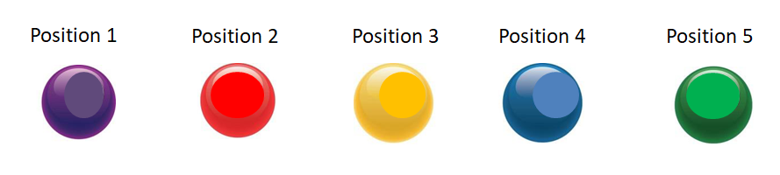

* Sample ball position Set B – Dice values 3 or 4.

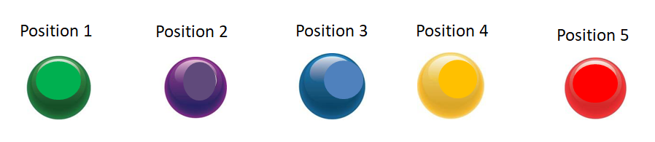

* Sample ball position Set C – Dice values 5 or 6.

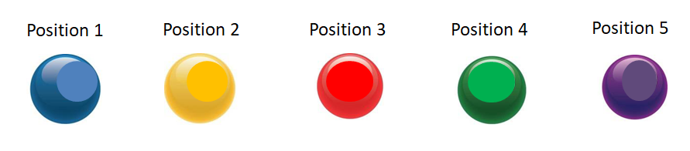

*The actual sequence or mapping of the balls and the dice value will be decided at competition site as a part of 30% change.*

**Section –C**

# **C. Marking Scheme**

The Assessment is done by awarding points by adopting two methods, Measurement and Judgments

* Measurement(M) –One which is measurable
* Judgments(J)-Based on Industry expectations

**Method:**

Flash cards are used for judgmental as shown in figure below.



* Three experts will do the judgment.
* Experts select a score between 0 and 3.
  + 0: performance below industry standard
  + 1: performance meets industry standard
  + 2: performance meets and, in specific respects, exceeds industry standard
  + 3: performance wholly exceeds industry standard and is judged as excellent
* Experts display their scores at the same time and these scores are recorded.
* The set scores awarded must not differ by more than 1.
* If the scores differ by more than one, discussion is allowed, with reference to the detailed descriptor for each score, in order to bring the scores into the permitted range.

**Example-Judgment Marking**

If maximum marks for Judgment criteria is 1 and if all 3 Experts (Juries) give 3 points to a candidate, the candidate will get 1 mark for that aspect. If 2 Experts give 3 and 1 Expert gives 2 points, then candidate will get (3+3+2)/9*1 = 0.89 marks for that aspect out of 1 mark.

**The tasks for performance with allocation of marks are as follows**;

* + - * Criteria A - Work organization & Management - 10 Marks
      * Criteria B - Communication & Interpersonal Skills – 10 Marks
      * Criteria C – Design – 25 Marks
        + Base Unit Core mobility performance
        + Simple Object Handling Task
        + Fabrication and Assembly
* Criteria D - Fabrication & Assembly – 05 Marks
  + - * Criteria E - Programming, Testing & Adjustment

(No Direct Line of Sight) – 25 marks

* + - * Criteria F - Programming, Testing & Adjustment

(Direct Line of Sight and Autonomous) – 25 marks

**The Detailed Marking Form is attached as Annexure**

**Section - D**

# **D. Infrastructure List**

**The Organizers are responsible to arrange for the Play Field of Particle Board.**

**The Items required for the Competitions are as follows;**

* Particle board of 4m by 2m with a white PVC sheet coating on one side.
* Black Electrical insulation tape.
* Grid pattern printed on white paper of size 10 mm X 10 mm.
* No restriction for use any sponsored / make of components except the use of myRIO and labVIEW are mandatory
* Transparent plastic sheet 1381 mm X 200 mm X 6 mm.
* Billiard Balls set.
* Parent grid pattern.

**Section –E**

# **E. Instructions for candidates**

* Experts shall not be allowed to give any help to Competitors to interpret the Test Project except where agreed by the Jury before the start of the competition
* Competitors have the right to expect fairness, honesty, and transparency during the Competition
* Every Competitor has the right to expect that no other Competitor will receive unfair assistance or any intervention that may provide an advantage
* Interference by officials or spectators that may hinder or assist Competitors in the completion of their Test Project is forbidden
* Accredited personnel at the Competition shall ensure that the above principles of honesty, fairness and transparency are observed at all times
* When the Competition is over, Competitors shall be given time to exchange views and experiences with other Competitors and Experts.
* In case a Competitor has to withdraw due to illness or accident; marks will be awarded for the work completed.
* In the event of Competitor fall ill or has an accident, it must be informed to Expert (Jury member)

**Section –F**

# **F. Health, Safety, and Environment**

Following are the suggested personal protective equipment’s during the competition.

* + - Safety footwear - Mandatory and all time
    - Protective gloves - While doing drilling operation

(If Required)

* + - Protective glasses / face protection - While doing drilling operation

(If required)

1. All accredited participants and supporting volunteers will abide by rules and regulations with regards to Health, Safety, and Environment of the Competition venue.
2. All participants will assume liability for all risks of injury and damage to property, loss of property, which might be associated with or result from participation in the event. The organizers will not be liable for any damage; however in case of Injury the competitor will immediately inform the immediate organizer for medical attention.

**Mark Summary Form for Level - I Competition**

Skill: 23 – Mobile Robotics

Name of Competitors: 1.__________________ 2.___________________

|  |  |  |  |
| --- | --- | --- | --- |
| **Aspect ID** | **Description** | **Max. Marks** | **Marks Obtained** |
| **A** | **Work Organization & Management** | **10** |  |
| A1 | Co-operative Behavior with Compatriot Team Member | 5 |  |
| A2 | Team Space Condition | 5 |  |
| **B** | **Communication and Interpersonal skills** | **10** |  |
| B1 | Review of the Engineering Journal Frame / Structural Section | 2 |  |
| B2 | Review of the Engineering Journal Wiring Section | 2 |  |
| B3 | Review of the Engineering Journal Mobility Management Section | 2 |  |
| B4 | Review of the Engineering Journal Object Management Section | 2 |  |
| B5 | Review of the Engineering Journal Computer Programming Section | 2 |  |
| **C** | **Design** | **25** |  |
| C 1.1 | A Flat Plate is brought into the Sensor Field and the Robot must AUTONOMOUSLY make a predetermined response such as Blink a LED | 4.00 |  |
| C 1.2 | A Flat Plate with a Black Tape Line on it is brought into the Sensor Field and the Robot must AUTONOMOUSLY make a predetermined response such as such as Blink a LED | 2.00 |  |
| C 2.1 | The Robot must complete a 1 M Forwards movement in the Open Playground Smooth Floor Space at one button press. | 2.00 |  |
| C 2.2 | The Robot must complete a 1 M Backwards movement in the Open Playground Smooth Floor Space at one button press | 2.00 |  |
| C 2.3 | The Robot must complete a Full 360-degree rotation while remaining in a Tape Line defined Square at one button press. | 5.00 |  |
| C 2.4 | The Robot is placed in a position of the Team's choosing relative to a Designated Ball on the game field. The robot has to pickup the ball and hold it without touching the ground. | 10.00 |  |

|  |  |  |  |
| --- | --- | --- | --- |
| **Aspect ID** | **Description** | **Max. Marks** | **Marks Obtained** |
| **D** | **Fabrication & Assembly** | **5.00** |  |
| D 1 | Wiring installation meets Industry Standards for secure / safe installation Examination of the Robot’s Wiring (secure wire placement, efficient wire organization, quality of connections, protection from Abrasion, inclusion of appropriate fusing and master safety switch) | 2.00 |  |
| D 2 | Frame Assembly meets Industry Standards for fit and alignment of components Examination of the Robot Frame’s Structural Integrity (fit between connected components, accuracy of component alignment angles, sizes etc.) | 1.00 |  |
| D 3 | Object Management System meets Industry Standards for fit and alignment of components Examination of the Object Management System’s Structural Integrity (fit between connected components, accuracy of component alignment angles, sizes etc.) | 2.00 |  |
| **E** | **Core Programming, Testing & Adjustment**  **(No Direct line of Sight)** | **25.00** |  |
| E 1.1 | The Robot's operational Safety Light Performance | 4.00 |  |
| E 2.1 | Robot exits out of the start position and travels the length of the game field to first parents booth | 2.00 |  |
| E 2.2 | Robot exits out of the start position and travels the length of the game field to second parents booth | 2.00 |  |
| E 2.3 | Robot exits out of the start position and travels the length of the game field to third parents booth | 2.00 |  |
| E 3.1 | Robot successfully positions itself in front of Designated first Parent Grid Pattern | 2.00 |  |
| E 3.2 | Robot successfully positions itself in front of Designated Second parent Grid Pattern | 2.00 |  |
| E 3.3 | Robot successfully positions itself in front of Designated third Parent Grid | 2.00 |  |
| E 3.4 | Successfully delivers the ball into the first parent booth. | 3.00 |  |
| E 3.5 | Successfully delivers the ball into the second parent booth | 3.00 |  |
| E 3.6 | Successfully delivers the ball into the third parent booth | 3.00 |  |

|  |  |  |  |
| --- | --- | --- | --- |
| **Aspect ID** | **Description** | **Max. Marks** | **Marks Obtained** |
| **F** | **Core Programming, Testing & Adjustment (Direct line of Sight and Autonomous Mode)** | **25.00** |  |
| F1.1 | The Robot's operational Safety Light Performance | 1.00 |  |
| F 2.1 | Robot exits out of the start position and travels the length of the game field to Archway Entrance for first child. | 1.00 |  |
| F2.2 | Robot exits out of the start position and travels the length of the game field to Archway Entrance for second child | 1.00 |  |
| F2.3 | Robot exits out of the start position and travels the length of the game field to Archway Entrance for third child | 1.00 |  |
| F3.1 | Robot successfully positions itself in front of Designated first Parent Grid Pattern autonomously. | 2.00 |  |
| F3.2 | Robot successfully positions itself in front of Designated Second parent Grid Pattern autonomously. | 2.00 |  |
| F3.3 | Robot successfully positions itself in front of Designated third Parent Grid autonomously. | 2.00 |  |
| F3.4 | Successfully delivers the ball into the first parent booth autonomously. | 3.00 |  |
| F3.5 | Successfully delivers the ball into the second parent booth autonomously. | 3.00 |  |
| F3.6 | Successfully delivers the ball into the third parent booth autonomously. | 3.00 |  |
| F3.7 | Robot exits out of the archway of the game field from first parent grid autonomously. | 2.00 |  |
| F3.8 | Robot exits out of the archway of the game field from second parent grid autonomously. | 2.00 |  |
| F3.9 | Robot exits out of the archway of the game field from third parent grid autonomously. | 2.00 |  |